**A PROJECT REPORT ON**

PERFORMANCE EVALUATION AND DETECTION OF MALWARE

SUBMITTED IN PARTIAL FULFILLMENT FOR AWARD OF DEGREE OF

**BACHELOR OF TECHNOLOGY**

IN

# COMPUTER SCIENCE AND ENGINEERING

By AAYUSH KUMAR

*(2001320100002)*

ABHISHEK SAXENA

*(2001320100010)*

ANJILA CHOUDHARY

*(2001320100026)*

AZHARUDDIN ALAM

*(2001320100041)*

UNDER THE GUIDANCE OF

MR. ASHWINI KUMAR VERMA



**DEPARTMENT OF COMPUTER SCIENCE AND ENGINEERING GREATER NOIDA INSTITUTE OF TECHNOLOGY, GREATER NOIDA**

**Dr. A.P.J. Abdul Kalam Technical University, Lucknow**

**MAY, 2024**

# BONAFIDE CERTIFICATE

Certified that this project report “**Performance Evaluation And Detection Of Malware**” is the bonafide work of “**Aayush Kumar, Abhishek Saxena, Anjila Choudhary and Azharuddin Alam**”who carried out the major project work under the supervision of “ **Mr. Ashwini Kumar Verma**”. Certified further that to the best of my knowledge the work reported here in does not form part of any others report on the basis of which a degree or award was conferred on an earlier occasion on this or any other.

**Signature Supervisor**

# ACKNOWLEDGEMENT

I would like to express my profound gratitude to **Dr. Sandeep Saxena, Head of Department of Computer Science & Engineering** and **Dr. Dhiraj Gupta, Director of the Institution** for their contributions to the completion of my project titled **Performance Evaluation and detection of malware**.

I would like to express my special thanks to our mentor **Mr. Ashwini kumar verma Assistant Professor in Department of Computer Science & Engineering** for his time and efforts he provided throughout the semester. Your useful advice and suggestions were really helpful to me during the project’s completion. In this aspect, I am eternally grateful to you.

In the end, I would like to thanks to my parents, who were extremely sincere and loyal with me at every stage of my career. My parents were always there to support me in difficulty times. I was able to complete my thesis due to their efforts too. My parents are my real support my pillars.

I would like to acknowledge that this project was completed entirely by me and not by someone else.

**Aayush Kumar Abhishek Saxena Anjila Choudhary Azharuddin Alam**

# TABLE OF CONTENT

BONAFIDE CERTIFICATE i

ACKNOWLEDGEMENT ii

TABLE OF CONTENT iii

LIST OF FIGURES v

LIST OF TABLES vii

LIST OF ACRONYMS AND ABBREVIATIONS viii

ABSTRACT ix

1. INTRODUCTION 1
   1. Problem Definition 4
   2. Aim and Objective 6
   3. Malware. 6
      1. Types of Malware. 9
      2. Types of Malware Analysis. 23
      3. Types of Malware Detection. 30
   4. Structure of Project 35
2. LITERATURE REVIEW 36
   1. Background Study 36
      1. Comparative Analysis of Research Papers 39
3. SYSTEM ANALYSIS 44
   1. Tools and Technology Requirements 44
      1. Python. 45
      2. Google colab 46
      3. Pycham 47
      4. Pandas 48
      5. Numpy 49
      6. Scikit-Learn. 50
4. FEASIBILITY STUDY 51
   1. Technical Feasibility 51
   2. Economical Feasibility 52
   3. Operation Feasibility 52
   4. Legal and Regulatory Feasibility 53
   5. Market Feasiblity 53
5. METHODOLOGY 55
   1. Overview of Methodology 55
   2. Implementation 55
      1. Preparing the Dataset 58
      2. Learning Algorithm and their performance 62
6. CONCLUSIONS 75
   1. Conclusions 75
   2. Future Scope. 76
   3. Applications. 77

REFERENCES 78

# LIST OF FIGURES

Fig 1-Desktop Operating system market share… 1

Fig 2-Different first generation malware 10

Fig 3- Encrypted malware 19

Fig 4-Oligomorphic malware 20

Fig 5-Polymorphic malware 22

Fig 6-Metamorphic Malware 23

Fig 7-Traditional Detection system 31

Fig 8-Malware normalization 33

Fig 9-Python 45

Fig 10-Google colab 46

Fig 11-Pycharm 47

Fig 12-Pandas 48

Fig 13-Numpy 49

Fig 14-Scikit-learn 50

Fig 15- Flow Chart of the Proposed System 57

Fig 16-Features of the dataset 59

Fig 17-Organizing dataset 59

Fig 18-Feature selection 60

Fig 19-Weight of Different Features 61

Fig 20-Splitting Dataset Size 62

Fig 21-Linear Regression 63

Fig 22-XGBoost 64

Fig 23-Confusion Matrix of XGBoost 64

Fig 24-Decision Tree 65

Fig 25-Confusion Matrix of Decision Tree 66

Fig 26-Random forest 67

Fig 27-Confusion Matrix of Random Forest 67

Fig 28-KNN 68

Fig 29-Confusion Matrix of KNN 69

Fig 30-Logistic regression 70

Fig 31-Naive Bayes 71

Fig 32-Confusion Matrix of Naïve Bayes 71

Fig 33-Stochastic gradient descent 72

Fig 34-Confusion Matrix of SGD 73

Fig 35-Support Vector machine 74

Fig 36-Confusion Matrix of SVM… 74

Fig 37-Analysis of different machine learning algorithms 75

Fig.38- Graph of Different ML techniques and their Accuracy 76

# LIST OF TABLES

Table 1- Comparative Analysis of Research Papers 39

Table 2- Pseudo Code for Conversion of PE Files to CSV Files 56

# LIST OF ACRONYMS AND ABBREVIATIONS

**ML** - Machine Learning

**AI** - Artificial Intelligence

**DDoS** - Distributed Denial Of Service

**Figure**- Fig

**Colab** - Collaborator **IOT** - Internet of things **OS** - Operating System

**KNN** - K nearest neighbor

**SGD** - Stochastic Gradient Descent

**SVM** - Support Vector Machine

# ABSTRACT

All this has become quite feasible given the breakthrough in internet technology and computer networking: high-speed shared internet. This leads to the everyday growth in number of computer systems which have turned into potential preys' for malware attacks. Malware is short for malicious software and refers to a program specifically engineered to cause damage to a computer, server or network. It could even send data to bad actors and allow them to access your information or systems without your permission. What are some common types of malware? Adware, fileless malware, viruses, worms, trojans or trojan horses, bots, ransomware and spyware. The first step to do so, is getting some data on PE files. PE stands for Portable Executable, which is the file format used for executables and several binary file types in all 32-bit versions of Windows operating systems. PE files (Portable Executable) are based on the COFF file format (Common Object File Format). exe) and dynamic linked libraries (.dll) as well as kernel modules ( Generally, a download manager enables downloading of large files or multiples files in one session. srv). srv). The next phase was to convert these PE files to.CSV format, so that we could extract important features like Filename, FileSize, Characteristics of file, ImageVersion Informtaion and OS version information (if possible), MD5 hash etc. from them: Having this enriched dataset in CSV, we will continue and use a variety of machine learning algorithms to identify patterns and derive value from it. Some of the notable algorithms used in this phase are Support Vector Machine (SVM), K-Nearest Neighbors(KNN), Random Forest etc. We have chosen each algorithm carefully in a way that each of them should significantly benefit when it comes to classification and analysis for the features extracted from PE files. By conducting this iterative procedure, we strived to acquire a comprehensive knowledge of the features and hazards concerning the PE files under investigation in order to further enhancing effective means for the practical detection of malware as well as security in Windows systems. Yet, our strategy is even more effective because it employs ensemble methods that synergize multiple machine learning models to increase the prediction success of both random forests and support vector machines. In Addition, incorporation of deep learning methodologies which includes convolutional neural networks (CNNs) and recurrent neural networks (RNNs) castlepling the PE file information can shed light not only on intricate patterns and connections but also decidedly Improve the malware detection Program.

# Chapter 1 INTRODUCTION

These days it is no more possible for anyone to imagine a world where there is no internet and the way technology is growing, the concept of cyborg appears to be more real. You are surrounded by technology; it might be mobile phones, laptop, smartwatch, transactions being made not in cash but by digital electronic money. Internet of Things is being worked on at an extensive amount and a lot of research work, time, and energy are being put up for the same to build Smart House, Smart City, etc., but everything is built through data and data here is key. But then it’s not that technology is flawless, it has its own flaws and vulnerabilities. For this project we are only focusing on laptops and desktops, and out of them too, there are more percentage of laptop users. Out of all the OS available, the maximum among them is even held by windows. NetMarketShare reports that, 76.32% of them use windows.

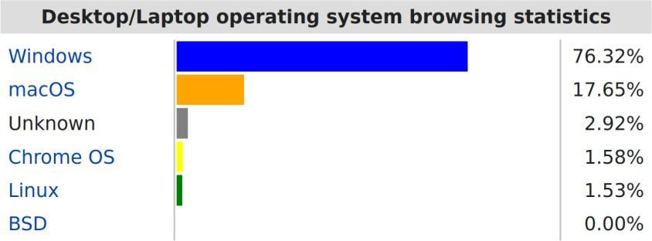

Fig. 1: Desktop Operating System Market Share

In our modern digital world, one of the most acute problems is malicious software, and it is only getting worse, unfortunately. Malware is any software designed to cause damage to a computer system or network. This may include, but is not limited to, using it for espionage and profit. Recently, malware has started to target embedded computation platforms, such as an IoT device, medical equipment, an E&I control system, etc. This appears as a result of the increasing prevalence of such platforms, which are a built-in part and, thus, are composed of embedded computing devices. Today’s malware is complex in terms of having a high degree of diversity, in other words, numerous strains have the ability to not only modify their code but also their

behavior, making it difficult to identify them. There is an enormous variety of malicious software in existence, that is why relying only on protectors based on signatures is not enough, and one needs an all-in-one toolkit.

Malware families share common traits, which can be seen either statically or in real- time in their numerous incarnations. These perceived patterns can be used to isolate families of malware. Static analysis comprises techniques of examing the content of malicious files without running them. Dynamic analysis also classifies the behavioral characteristics of malicious files, as opposed to performing such actions as tracking information flows, function calls, and dynamic binary fingerprinting. Machine learning techniques can be applied to a combination of static and behavioral artifacts that are used to represent modern malware’s metasrukturu changing structure. This makes it feasible to identify more sophisticated malware attacks that are otherwise almost impossible to detect using a signature-based detection approach. The strategies currently available based on machine learning are better than those using signatures when it comes to detecting newly-released malware, also known as zero-day malware. Furthermore, deep learning algorithms are able to produce even better opportunities for feature extraction and representation thanks to implicit feature fabrication.

The author considers the importance of machine learning in terms of dealing with potential cyber security risks. Having obtained the relevant data throughout your firm and compared millions of data points in the context of your clients, employees, and partners, it is evident that you would utilize only people to spot any possible threats. Specifically, machine learning and algorithms will serve as beneficial tools for viewing the obtained data in large data sets and predicting possible future security problems. Therefore, the author has highlighted that using machine learning and developing a relevant ML tool could serve as a beneficial implementation and will cover the purpose of identifying phishing websites.

In the conditions of current rapid changes in the field of cyber threats, machine learning and its implementation could become a significant part of the process of the proper preventive measures. Indeed, it can be assumed that having encountered the problem of collecting a large amount of data generated by network traffic, system

logs, and user activities, one can rely on using the timely existing information and auto systems.

The above mentioned ML tool will undoubtedly help your security engineers protect your clients and firm from cyber threats that happen every day and cannot be addressed late. Furthermore, they will also identify the phishing websites new to the cyberspace and provide information about any new existing addresses.

Machine learning systems can be trained on a large body of data consisting of legitimate as well as phishing websites to learn the features and patterns that define each. This can include such characteristics as URL, content of the HTML page, surrounding text, HTML page metadata, and other features. Such models can then be used to train machine learning models, exploiting both supervised learning, where the data is labeled as phishing or not, and unsupervised learning, where the algorithms is used to find patterns in the data without first been shown the classes.

Machine learning models in the context of phishing detection can, for example, use natural language processing tools to ascertain whether the website contains suspicious keywords, such as your account has been suspended, is asking for private information, or sensitive data should be sent via email, if the website has poor grammar, or breaks other feature. Additionally, other features, such as URL age, the presence of SSL certificate, and reputation score of website can be used.

Moreover, deep learning, a class of unsupervised learning, is now being used in phishing websites detection. Examples of deep leaning architectures are convolutional neural networks and recurrent neural networks, which excel at automatically determining patterns and extracting better features than those manually chosen by experts.

The benefits of employing machine learning in phishing websites is aplenty. First, it allows the analysis of a large number of websites, which would be otherwise unmanagable. Second, this approach is more resistant to changes in technology, because the machine learning models will update to detect such changes. Third, often, ensemble models might be used where multiple machine learning models are used,

taking advantage of many features, rendering them even more powerful and robust than the average classifier.

However, it has to be stated that ML are not a cure-all and are to be used alongside other security measures, such as user education, secure coding practices and regular software updating. Moreover, according to Goodfellow et al., Ml models are vulnerable to adversarial attacks, when the inputs are carefully designed by malicious actors to deceive the model. Thus, regular monitoring and retraining of the model might be necessary. To wrap it up, bit can be concluded that employing machine learning in cybersecurity is essential, considering the modern complex and everchanging landscape of threats. Phishing detection is only one example illustrating how these powerful techniques can help in the fight against cyber threats. It shows that cybersecurity should be approached from multiple sides and implemented at several levels.

# Problem Definition

With the increase in demand for the internet, risks of cyberattacks are also being increased. So, most organizations and people are experiencing problems with the malware files in their systems. It is too much difficult to save or protect important data from personal computer systems. There are several techniques that use to detect the malware that is present in computer systems. However, some traditional malware detecting techniques cannot perform valuable actions to detect the malware. Due to this, different kinds of malware that are present in different forms in computer systems cannot be detected. It means traditional malware detectors fail to detect malware that is present in the system. In this condition, there is a need for malware detectors that can detect malware more easily and comfortably. with machine learning algorithms we can detect malware that is present in a system, which provided better results in this area. For the future, machine learning algorithms will be of more use to detect malware that is present in systems. There are also many kinds of machine learning algorithms that use for the malware detection process. However, for this research, I just consider a few important machine learning algorithms that will be of more interest. One of the important machine learning algorithms is a convolutional neural network and recurrent neural network. CNN and RNN are deep learning

models that learn complex patterns and features from the data. So it will be more useful to detect variants of malware. Besides that, other important machine learning algorithms are decision trees and random forests. These techniques are used for learning data and make decisions from the learning process.

The proposed research encompasses running each of the specified algorithms on the required data to ascertain how efficiently it can detect malware. Specifically, the efficiency of the algorithms will be measured using a range of metrics. The performance of each of the models will be tested using such tools as accuracy, precision, recall, and F1 – score. The integrity and validity of the results will be assured by such techniques as cross – validation and stratified sampling and other tools that ensure that the process of data collection is conducted in the defined sequence. Data collection will be performed at the outset of the research and will imply the acquisition of the selected benign files and the set of malware samples. Preprocessing will be the following phase, and it will include conducting data cleaning, normalization, and other appropriate techniques required for the preparation of the data. In addition, encoding of the data will be necessary for the task to follow. Feature extraction will be the third key step in the process as, to achieve the anticipated effect, it is necessary to detect the most relevant features differentiating between malware and benign files. Static analysis for detecting data features in the headers, sections, and code segments will be employed alongside dynamic analysis testing files in a controlled environment. Both approaches will be employed to ensure the most effective features are chosen. The following step in the research process will be the training of the machine learning algorithms and testing how accurately they operate. The use of hyperparameter tuning, regularization, and ensemble methods will be integral to the training process. Finally, performance assessment will be conducted across the defined data set with test pairs as the output. In conclusion, the paper will also draw a comparison of the machine learning models applications, underscoring the benefits and shortfalls of each type.

I have read the abstract and find the research quite interesting as it aims to improve the existing malware detection systems by employing different machine learning classifiers. The research findings appear to be important since they will provide more

insights and enable readers to protect themselves and their business entities from the malware threat. I think the research has good prospects to succeed.

# Aim and Objective

The aim of this research is to detect malware and evaluate performance by initiating different machine learning algorithms.

The objective of the project is to analyze the importance of performance evaluation with respect to schema for the malware detection system. This is accomplished by exploring the impact of performance metrics in affecting the efficacy of malware detection algorithms. The aim of this report is also to:

* + - Evaluate the diverse performance evaluation methods employed in determining the efficiency of malware detection systems.
    - Investigate the impact of performance requirements such as the detection rate of malware detection systems.
    - Determine the challenges and limitations that are experienced when conducting the performance evaluation in the evolving landscape of malware threats.

# Malware

Internet technology and computer networking What is more, required the internet to be high speed shared. As a result of this development, to date, the number of computer systems prone to malware attacks is increasing daily[1][2]. The term malware is an abbreviation of malicious software. Researchers define it as any software that was specifically designed to disrupt a computer, server, client, or computer network, steal private information, gain unauthorized access to information or systems and to or deprive access to information or which performs that unknowingly compromises the user’s security, privacy and/or ethics[3]. Normally, researchers describe malware in terms of one or more sub-types or Equally, malware is regarded as harmful to all individuals and businesses that use the internet due to its various issues. In this modern era, the number of newly produced malware in the internet environment continues to escalate, while the antivirus companies are working

strenuously to limit this tendency so that the majority of computer users can be free from these threats isolation[4][5]. Notwithstanding, the over couple of years, malware have become more sophisticated, as a result, they are harder to detect. Consequently, newer, more effective ways have to be improved between now and the future to detect and avert these attacks. Malware is malicious software that attacks the privacy, reliability, and accessibility of a computer system’s data. This issue has made both academicians and industry practitioners move from antiquated, static detection techniques, to more dynamic, sophisticated, spontaneous methods relying on accumulated malware behaviour to constantly monitor systems for malware attacks[6][7][8].

Malware creation is an activity that can be linked to various actors with different motivations. Cybercriminals are inclined to do it with the aim of getting money. Hence, malware is likely to be created to steal banking details, credit card numbers, and passcodes, as well as to demand a ransom for illegally blocking some data. Additionally, malware can be developed by some nation-states willing to wage cyber warfare, and get some essential information whether it is critical infrastructure, government systems, or assets of the state. Moreover, malware is likely to be designed by hacktivists to achieve their ideological or political goals and gain access to data specifying their opponents or any organization they disagree with. Finally, malware can also be created by companies’ insiders who have some vendetta and want to take revenge on their previous employer. The potential implications of allowing my system to be infected are categorized as individual and organizational. I might suffer from the threat because my personal data is not likely to be secure with malware captured on the computer. Hence, running my home business, I can get my bank account, credit card numbers, and some programs details stolen. Both fundamental and so-called dirty secrets may come up and result in criminal gains. Moreover, my system in the workplace can be under risk. In other words, malware will infect the system at work, and I will be guilty of leaking some details of our projects and causing damage to the company’s reputation. As such, I am likely to be dismissed from the job. If my data is lost, my documents and significant papers can be eliminated, ruined, or put into a mess. My PC can be blocked, and I will need to spend a considerable amount to use the services of some experts to try to restore the

saved data. Alternatively, I can lose the projects that have already been completed and are being saved for the future crucial event.

To protect a computer from evolving malware threats, a multi-layered approach is needed to reduce the risks associated with these dangerous programs. First, security measures aimed at protecting the system from the influx of any malware should be in place. These measures can include updating software and operating systems regularly, using commercial or freeware anti-virus and anti-malware software, implementing firewalls and intrusion prevention or detection systems, and raising cybersecurity awareness among users. Second, regular backup of files and well-developed attack mitigation and recovery plans should be made. Third, the field of malware analysis and cybersecurity is constantly advancing, meaning that the research into malware detection and other prevention mechanisms is needed to improve protection.

Such research is especially needed because of the decreasing efficiency of traditional signature-based approaches. Such approaches can only identify malware by comparing it to known database entries. The authors of malware use various techniques to avoid such comparisons, including obfuscation, polymorphism, and metamorphism, and researchers, as well as cybersecurity specialists, should come up with more sophisticated and dynamic ways of dealing with emerging threats.

One direction where researchers can move is to leverage the powers of machine learning for malware detection purposes. Machine learning involves programming a computer to draw conclusions from data by identifying patterns or features based on training with large datasets. The technology-oriented approach means that data-driven pattern recognition can bring several benefits, including adaptability, generalization, automatic feature selection, and scalability. Several common machine learning methods can be used for malware detection tasks, such as decision trees, random forests, support vector machines, and neural networks. In addition, other unsupervised learning methods like clustering or anomaly detection can be used to identify different malware types, whereas deep learning neural network architectures like convolutional or recurrent neural networks can be used as a more sophisticated and more powerful ML tool. The use of machine learning to detect malware implies that the programs can be analyzed in terms of static features such as their binary code, headers, and other metadata or dynamic characteristics.

Although machine learning methods can offer solutions to the current malware threat, it is important to note that they are not a silver bullet. They can only provide beneficial results when used as a part of the complex approach, which merges them with other security measures and best practices. The efficiency of machine learning models is highly dependent on the training samples, and their diversity and quality, as well as the definition and proper application of valuable features. Furthermore, as it was mentioned above, the development of adversarial machine learning is transforming into a considerable problem, and malware authors will continue to construct samples, which cannot be recognized by the machine learning methods during quite a long time. In conclusion, it is possible to state that malware is still a major threat of the current century. With an increase in the number of devices used by people and their interconnectedness, the risk of malware infection will only grow. Thus, not only high-quality security measures and incident response plans but also people’s awareness and R&D activities focused on the development of the new techniques designed to reduce the risk and efficiently prevent and fight malware attacks, including machine learning methods, have to be implemented.

* + 1. **Types Of Malware** There are two types of malware:- A.First Generation Malware

B. Second Generation Malware

## First Generation Malware

The first generation of malware is static malware. It is classified based on attack methods: viruses, worms, and trojans. A virus spreads by attaching itself to normal files in the user’s applications and share through human actions. On the other hand, worms replicate themselves in similar manners but exploits network vulnerability while spreading. Meanwhile, trojans trick the user by disguising themselves as useful software. More types of malware received this classification, such as rootkits, that gains unauthorized administrative access, hides its presence, and punishes its detection by altering system behaviors. Variants of this malware include spyware that gathers information about the user without permission, crimeware with the intent of facilitating online crime, and adware that delivers advertising material without

permission. Despite the different purposes these malware have, they share similar aspects of their goal and design.

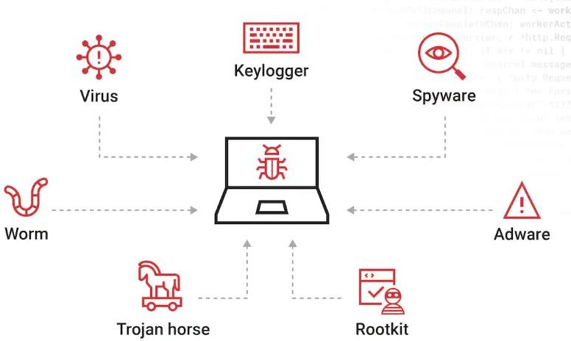

.

## Trojan Horse

Fig. 2: Different First Generation Malware

A trojan is a kind of malicious software which pretends to be safe and useful software, imitating legitimate software to trick a user. However, when a user starts the application, it lets out malicious codes which may ruin the files and the applications installed on a computer. Moreover, a trojan can steal some sensitive information, such as passwords or personal data. While computer viruses and worms can spread on their own, trojans require the users’ help to get started and multiply, often in the form of a deceptive download. For this reason, trojans are one of the most harmful and dangerous types of malware as they are usually the source of serious and irreparable harm. Trojans are often not detected until the damage is done[9]. The nature of a trojan which causes it is to be discovered too late mostly as they are usually recognized only after they have reached and damaged a system, makes it almost impossible to prevent it from entering and eliminate it from the system. Thus, as one of the most serious and dangerous computer threats, it is noteworthy that trojans tend to cause considerable harm to the systems they have attacked and severely affect the users. The nature of a trojan to be late-discovered threat is closely and extremely tightly connected with another one of the noticeable characteristics – the fact that

trojans cause more harm than they should. Since trojans are able to go past all the first security measures and remain undetected for so long, their effects are serious indeed. Hence, it is evident that a trojan deserves the label of amajor threat of a type of computers.

## Virus

A virus is a self-replicating type of malware created to change the functionality of a computer. It infects overloaded one software product and generated itself from other useful application software programs so that the virus cannot spread, as is the case with a trojan horse. Depending on intensity, it can cause tremendous harm to the computer system. It can lead to premature transfer, irrelevant information, discoloration of the screen and blur. When a virus begins a Denial of Service attack, it launches an unmanageable number of requests to the point where the system shuts down and can no longer be accessed normally. These viruses can corrupt computer files and spread to other programs. The virus may exceed to more than one system on an individual network. They may also give the computer all the systems and data drives they can access. The data may be corrupted or deleted indiscriminately. They also surpass the system to gain access to certain reliable records. More severe, the virus is a risky virus that gives the virus access to the system in different ways which hackers use to take advantage of the relieved system. These viruses are also dangerous in that they can self-replicate themselves like an infected area on the below bits.networks. This enables the virus to spread widely across the network without being found. To this end, then, we must create reliable and security-producing computers and networks, installing up to date virus checks and updating software without fail.

## Adware

Adware is a relatively low-danger type of malware that differs with the degree of its functional influence on the infected device. Its only task is to show advertising to the user. Unlike more dangerous types of viruses or worms that are designed to damage the system or misuse the infected device, adware collects information from it, such as information about the history of searches and visited webpages. Then it uses this information to display commercials on the infected device in which the user might be interested. That is why sometimes there may appear ads on one’s screen that are

connected to the product that the person has recently searched for or paid attention to. Nonetheless, such software is not as dangerous as many other types of malware, since the information is not likely to be personal, narrowing one’s interest. However, it is still rather annoying, causing automatical appearance, unwanted ads and other similar content, which prevents the user from satisfying work.

Furthermore, the device may be under some threat since the collection of information is carried out without the awareness and permission of the user, meaning that no one can tell how carefully and where it is used. Finally, in case the collected data is too big, it gathers in the infected device, overloading it with unnecessary information and reducing the work speed. At first glance, the impact of adware on the device is not really dangerous, but it can be a rather annoying and disturbing problem that may cause inconvenience during work. However, the key factor that makes it dangerous is that the device, to which such software is directly linked, gathers information about the user that is not always appropriate, followed by a lack of control over its proper use. Despite other types of malware, it is not lethal, but yet it affects the device’s work[10].

## Spyware

Spyware is a kind of applications that executes without the user’s approval and often without the user knowing that this software is running. Spyware is a self-installing malicious software that replicates on the target system. It is used to garner and trail information about the person and their browsing history of a computer system. The nature of what it records automatically varies and can involve, but is not restricted to, the types of websites the user attends, statistics of their computer practice, and even a copy of their transactions. Generally, spyware is bundled with freeware software. The unsuspected distribution of the software has made it common for users to unknowingly install spyware along with the more legitimate free software applications. Spyware functions without the user’s awareness, aggregating statistics inclusive of but not limited to statistics of what the person types via their keyboard, websites they frequent and their private information. The information can be sent back a third party that uses the data for a number of applications including advertising, identity theft, or unlawful access of information. Because of its skill to function without the user knowing, spyware is a very common issue for people

surfing the net. It is occasionally referred to as a rootkit both because of the way it is distributed by the freeware software and as it can hide its records on the user’s system without the user knowing it is there[11]. Spyware differs from other kinds of malware in that it does not damage the user’s computer system, nor does it disrupt it. Instead, spyware’s sole operation is surveillance that allows a third party to spy on the host. This feature makes spyware one of the most dangerous kinds of malware, as it can easily lie on a user’s computer system for an extended period of time without the user knowing that the information on their computer is being harvested. In order to avoid spyware, it is imperative that users use reliable anti-spyware software combined with the general rule of caution when downloading freeware applications from unknown websites.

## Worm

A worm refers to a form of malware that does not fuse itself to any additional software, a millennium that sets it apart from the virus. Viruses require a host program onto which they install themselves to migrate. Worms however migrate without necessarily requiring a host software on which to fasten. They move individually and fast across systems, and networks, take advantage of system vulnerabilities, and exploit computer networks and software. Typically, they expose an area of vulnerability, moves through the area infecting the target. Examples include open ports and poor password protocols that allow the worm to infect its target. Once inside the system, the worm uses strategies to migrate to another system, such as sending a similar copy to the computer through an email, an IM, or across network shares. Alternatively, worms exploit software vulnerabilities automatically to spread infections rather than requiring on the user for decision. Fly-and-exploit- capabilities of the worm, a variable that facilitates triggering of a highly influential attack. Worm threats to information system and system’s network lie in its capacity to corrupt systems configuration, inhibited network speed, and overly interfacing, which develops a DDoS case. To curb worms, a system is supposed to be highly secure with regular software updates and a well-managed, sophisticated network to detect and mask such an attack.

## Bot

A bot, also referred to as a web robot or botnet, is application software destined for automated tasks performance over the internet. Bots are a type of malware that allows gaining access to the infected computer system by the operator. Unlike viruses or worms, which are standalone pieces of software, bots operate in a larger network of infected computers called a botnet. The ability to propagate a bot is granted by backdoors that are installed on a victim computer by a virus or a worm. These backdoors allow their operator to create a central control server that is used for adding and controlling bots. Once installed onto a system, bots are capable of sending spam emails, conducting Distributed Denial of Service attacks, stealing valuable data, and spreading other malware. Bots are often employed by criminals to orchestrate large- scale operations, targeting compromised systems for financial gain and other malevolent purposes. Being able to operate fully automatically in the background, bots are often left unnoticed by their operators for long periods. Protecting against bot infection requires robust cybersecurity measures, such as antivirus software, firewalls, intrusion detection systems, and running timely software updates. Additionally, user education and avoiding opening suspicious links and downloading email attachments are imperative.

## Ransomware

Ransomware is a subgenre of malware which intends to demand payment from their victims by encrypting either the files on their computer or entirely locking them out. This malicious software locks the victim’s files out of use by encrypting them and turning them into what is effectively gibberish that cannot be used. Victims must usually pay a ransom, often in the form of cryptocurrency, so attackers will provide them with the decryption key needed to unlock their files. The key is saved to memory in order to decrypt the victim’s valuable files; without it, their access remains permanently restricted. Ransomware infections are mostly distributed by trojans, which deceive users into downloading and opening ransomware on their systems. After that, ransomware quickly spreads and encrypts all the files on your computer or network (where you are working) as much as possible. Ransomware attacks already provide a big payday to some cybercriminals, who can demand large sums from victims in return for their data being decrypted. There's no promise

payment will even lead to the return of the ransomed files -- and victims can end up losing money twice, by having handed over cash in Bitcoins or other cryptocurrencies they held as well as lost other valuable data. Ransomware infections can be fought and averted by implementing solid cybersecurity strategies such as safe data backups, good antivirus preventative measures, and end-user training to help users acknowledge suspicious emails or downloads. Organizations should also take appropriate network security action including firewalls and using intrusion detection systems to identify ransomware threats and then infect before they causes harm[12].

## Rootkits

Rootkits are a collection of computer software, typically malicious, designed to enable access to a computer or an area within...(Web definition) Rootkits are mainly intended to hide the hacker's performance and their role inside the crappy program, smoothly doing what from an administrator position without being caught by a target host. Rootkits prevents the user from detecting unauthorized access & manipulation of their system. As it hides any file changes and other nefarious activities that may be going on your operating system Trojans, worms and viruses are all associated with the hidden software components used to install rootkits but are not a log of it. installing rootkits onto systems allowing them to alter core system files and processes in a manner that is practically undetectable by antivirus software or other security measures. Attackers can intercept systems calls and network traffic as well, allows nice attacker to stay in control with out being noticed. Cybersecurity professionals face any number of problems related to rootkits, including the issues that they can fail to identify themselves or hide what they are doing in a way that makes them difficult (or impossible) to eliminate. Advanced security tools and methods, such as rootkit detection software, system monitoring, and forensic analysis, are necessary for identifying and containing rootkits. Ensuring that rootkits can be avoided and their effects on computer systems and networks minimized is through the use of regular software updates, user education to avoid such infections as well[12].

## Backdoor

Backdoor is a type of malware that creates an additional hidden “entrance” for malicious people into the infected system. A backdoor, unlike other types of malware, does not destroy the system itself. Instead, it acts as a backdoor for them to gain an

entry-point into your system and use this access to cause malicious activities. 16 Although backdoors can be used alone, they are often deployed in combination with other types of malware or as part of other attack packages.Aggressive Cyber Activity After this, backdoor gives them a sneaky way to break into the system and access it without going through the standard procedure. So now they can launch additional attack or perform any kind of bad operation on compromised machine from that vantage point. Backdoors might be used, among other things, to steal sensitive information, install a range of malware beyond the backdoor itself to spy on the victim or perpetrate DDoS attacks. Because of their covert operations, backdoors can sometimes go undiscovered in breached devices for weeks or even years, providing the attackers long-term access and reign. Advanced cybersecurity is required to detect and mitigate backdoor infections, which typically include monitoring systems regularly, conducting vulnerability assessments, and deploying intrusion detection systems. Moreover, user education and awareness have to be done; backdoor infections need abolished while systems and networks harm should also be diminished[12].

## Keylogger

Keylogger is a type surveillance malware (short for keystroke logging) to use of logging every keystrokes on system and it supports ability recording by software or hardware once the target has been affected. The spyware runs silently, monitoring everything the user types on their keyboard – including logins entered into applications and web browsers, as well The operating system's own password box. These recorded keystrokes are then saved to a log file which is typically encrypted and sent back using an RSA key ( This secure socket layer of the application actually decrypts data packets transmitted fromt eh targets as well). This sort of information could range from passwords to BVN and data related to the make or model of an ATM card. It might also include exposed credit card details provided by the user — whatever amount of misinformation you wish QPointFündunkt The method of deployment can be through email attachments, software downloads infected with a virus or from compromised web pages. Keyloggers could quietly collect keystrokes produced by the user they were installed on, operating out of sight and mind only to report back all data entered through their host. attackers could use the captured data for identity theft, financial fraud, cyber espionage or other nefarious activities[13].

Keyloggers can be difficult to detect and remove, as they are designed (to intentionally avoid detection), module-based, and often written with rootkit functionality. To avoid infection from keyloggers, it is important to follow cybersecurity best practices such as updating software regularly, installing reliable antivirus software and educating users about the dangers of following unsolicited links or downloading email attachments. Furthermore, the reliance on security applications like a firewall and intrusion detection system (IDS) provides an extra layer of defense and ensures timely identification and protection from keylogger attacks.

## Second Generation Malware

Second-generation malware, otherwise referred to as dynamic malware, operates on a more sophisticated level where the framework of the malware changes with each infection; generating new variants while keeping core intentions intact. These versions are especially designed to defy detection by security protocols, constituting extreme difficulties for cybersecurity experts. Classically second-generation malware can be categorised on the grounds of mechanisms used to obscure either code or the structure of malware itself which in turn makes it difficult for its signature to detect.

While this trend in the malware creation lifecycle is leading to more capabilities, it poses a difficult challenge for cybersecurity professionals who need to identify new ways of detecting responsive malware. Traditional methods may not get there fast enough because dynamic virus programs keep evolving. Attackers use different obfuscation methods to hide the actual code of malware so security solutions do not detect and stop threats as well as they should. Consequently, to detect and immediately respond to these dynamic threats, organizations need proactive security solutions like behaviour-based analysis coupled with threat intelligence. “Furthermore, the importance of user education and awareness cannot be understated in helping to avoid these types of infections,” SafeBreach Labs added. “Users need to actively protect themselves against social engineering attacks orchestrated by threat actors attempting to infect endpoints with malware-based payloads.” * With insight into the latest threat trends and strong cybersecurity solutions, this should enable organizations to better defend themselves from what seems like new threats with second-generation malware.

## Encrypted Malware

At the first level of concealment, we have encryption. Here the malware body consists of a encrypted malicious code along with key and encryption/ decryption algorithm [Fig. 3]. This XOR’s the body of the malware with the generated key, making it harder to detect. The primary goal for developing the malware with encryption, was to bypass the static code analysis and classical signature based detection method. Once it infects the system, after decrypting itself by using decryption algorithm and a key. It will again encrypt by encryption algorithm to produce new variant’s key for another type in order to bypass the detection mechanism. In the scope of malware, encryption is also found to be the primary obfuscation method: when it comes to concealment, malicious code usually resides in a shell where its body has been encrypted and, along with an algorithm and key for encrypting/decrypting. With all above MOV checks in place, there won't be any proper visible method to detract the actual nature of malware like Fooling static code analysis as well as traditional signature-based detection and attack. In this approach, the body of the malware is usually XOR’ed with a key which is generated dynamically which can makes it hard for security solutions to detect and analyze. Once received, the encrypted malware decrypts itself with the previously supplied decryption algorithm and key. At this point, the malicious code can be executed on infected systems. Upon execution, the malware re-infections itself for each variant using the encryption algorithm to create a new key after activation and gains changeover thwart at assorted levels. In most cases, such continuity of the encryption and decryption process results in a constantly changing structure of an evolving threat that is extremely difficult to parse or analyze for security researchersbf. This allows malware authors to hide their illicit actions using encryption, enabling compromised systems to be used long after a malware is initially installed. As a result, detection and mitigation strategies from cybersecurity professionals must change to address the continuum of threats posed by encrypted malware. It highlights the importance of advanced security solutions that leverage behavior-based analysis, machine-learning and threat-intelligence to effectively detect and neutralize encrypted malware threats in real time. In addition, ensuring that antivirus signatures and intrusion detection systems are updated regularly is essential to ensure your ability to keep ahead of any new encryption techniques used by malware authors. Organizations can prevent and

protect themselves from these harmful impact of malware attacks by taking measures in respecting to Encrypted Malware.

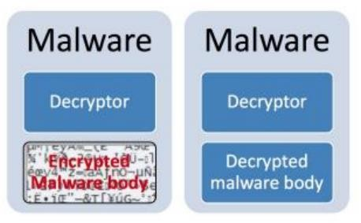

Fig.3 : Encrypted Malware

## Oligomorphic Malware

The limitation of the malware were encrypted, i.e., invariance properties of the decryptor within those specific variants of ma1-ware easily allowed an anti-malware to detect it by searching for signatures of their precious little boys—themselves. Therefore, various concealment techniques have been evolved to escape from this detection mechanism. In this malware (Fig. 2) 4) Decryptors: In this malware variant decryptors are mutated it means that we have pass through the set of obfuscated decryptors. Following these signs, the disadvantage of encrypted malware should be mentioned: is that since invariantness exists in decryptor within certain subtypes of malwares, it was and simply identified by the anti-malware solution by recognising signature for the decryptors. This gap soon led to the discovery of multiple kinds of hiding techniques, designed to trick detecting mechanisms. In response, malware authors continued to evolve their design by obscuring the decryptors with new features such as mutation of the generic elements across different variants (see for example [27]). Figure 4. An example of the advanced variant, where decryptors are muted[variant-wide pool of obfuscated decryptors] and dot`erent across different variants This is especially important because by constantly mutating the decryptors, malware developers can blur their “signatures”, making it harder for anti-malware solutions to detect and destroy the threat. Centrifuge then dynamically encrypts and decrypts its files, making it even harder for ordinary security mechanisms to detect the malware. Employing the low-level obfuscated decryptors gradually adds an

additional level of complexity to overall malware analysis. Understanding these behaviors, as well as proper toolsets and techniques for detecting this actor’s activity will enable defenders to analyze ROOTKIT040903 properly and develop detection measures that can be employed instantly. So, in conclusion, the arms race between malware authors and those who are trying to protect their networks whether it be CIOs or IoT operators has just become more intense. It is war and there is no winner yet. Against the threat of mutated decryptors or other more sophisticated obfuscating methods, combating and defending through proper cybersecurity tools should be a simpler choice — organizations must approach it with modern solutions backed by artificial intelligence (AI), machine learning, and proactive behavioral analytics. In addition to this, the security community must work together and share intelligence about cyber threats to get ahead of recurring attacks and implement defenses for new strains of malware as quickly as possible.

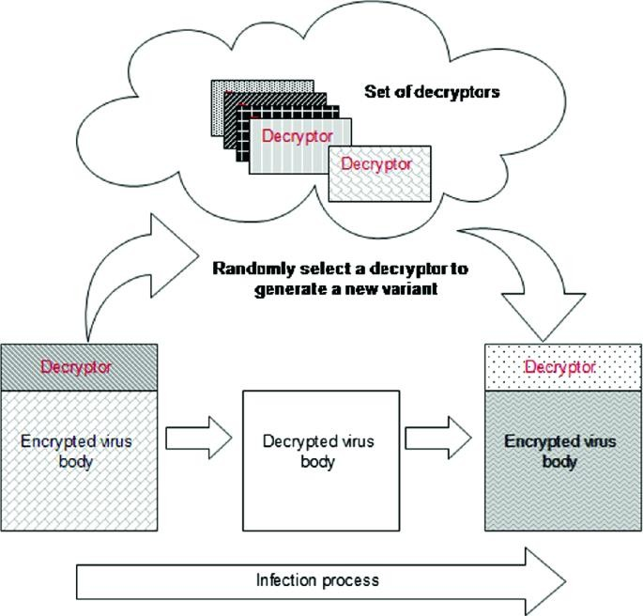

Fig. 4: Oligomorphic Malware

## Polymorphic Malware

It is similar to Oligomorphic Malware, whereas it can produce millions of decryptors by changing the instructions in variant os malware [14] so the signature matching detection technique will not work against this. The mutation engine produces an encryption algorithm and a decryption algorithm, where the malware code and this

mutator both are encrypted. In this way we get a new variant of that particular malware.A polymorphic malware which includes a body and decryptor; Polymorphic malware is somewhat similar to oligomorphic malware, but it highly elevates the obfuscation game. Polymorphic variants create millions of decryptors by mutating instructions used in malware variant The dynamic mutation process is designed to prevent the patterns from detection techniques, such as signature matching used in antivirus software and other filters. In contrast with the static type, when polymorphic malware uses a mutation engine to produce variant Generate_decryption_algorithm given an encryption algorithm Subsequent to writing the above process: algorithms are used to encrypt not only the malware code, but also the mutation engine; thus producing a new variant of that malware. Polymorphic malware structure: as shown in (Fig. 5). Polymorphic malware is generally 2 main parts including’ decryptor ’and body of the malware. The function of a decryptor — to decrypt the encrypted malware code so it can be run on the infected computer to perform its malicious purpose. This part of the malware actually consists of the payload and functionality of the malicious software. Polymorphic variants evade static signature or pattern-based security solutions that rely on the same instructions remaining in all received samples, by constantly changing their instructions and producing new strains with different decryptors. As a result, polymorphic malware behaves dynamically which allows it to be difficult for detection and resistant to traditional approaches taken with more common types of security implementations (like static signature-based analysis). Organizations are best served defending against the threat of polymorphic malware by implementing sophisticated cybersecurity strategies combining behavior-based analysis, machine learning and threat intelligence to identify and stop new threats as soon as they appear. Also, don’t forget to periodically update the Anti-virus signatures and intrusion detection systems. After all is, you will have to outsmart each person who created polymorphic malware if you want to stay ahead of it. Remaining ever- watchful and at the ready allows organizations to genuinely protect themselves from polymorphic malware, as well as all manner of other threats that continuously infiltrate our cyber realm.

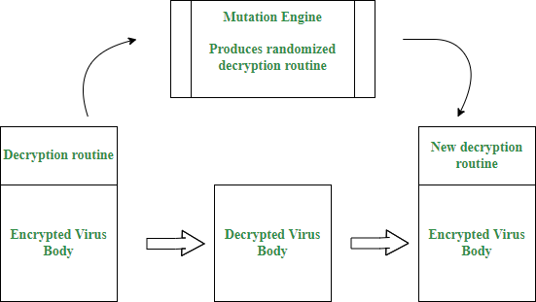

Fig. 5: Polymorphic Malware

## Metamorphic Malware

In Metamorphic malware shown in Fig. 6, rather than making the decryptors mutants, the malware body is mutated instead, i.e., the body, to create a new variant in which its actions remain the same, to avoid detection. The metamorphic behavior is achieved by using several obfuscation methods, similar to polymorphic malware for creating the variants, such as dead-code insertion, data modification, control/data flow modification, register renaming, subroutine permutation, equivalent code substitution, and so forth. Metamorphic malware “depicts that a different approach is adopted where instead of mutating the decryptors, the malware itself, the body, is mutated called a body-polymorphic transformation. The metamorphic behavior is achieved via this approach, where the underlying actions of the malware are preserved the same, thus enabling the malware to create a new variant with the resemblance of Polymorphic malware; however, the malware code is different in structure and appearance from the previous variant. This metamorphic malware variant is dynamically different each time where various polymorphic obfuscation techniques are applied that erases the earlier structure and functions of the malware and create a new one as a mutation. It keeps multiplying the code every cycle such that every iteration is unique concerning the looks. Since the Malware is meeting new lines of code and multiple workarounds, the signature method is rendered futile. . Since the Malware is updated dynamically, it does not portray a definite image hence alternative methods to detect it should be involved. An example is the use of a body- polymorphic transformation as portrayed in Figure A more dynamic variant is always

anticipated and hence one code is always mutating to another code. It deviates from all previous copies. As the security software is inactive or does not denote any infections in some scenarios, this mutation makes static analysis impossible and the malware is free to operate secure. To conclude, the use of body-polymorphic transformation or other tactics allows Metamorphic malware to stay long enough without anyone identifying it. The body-polymorphic transformation issued by the malware renders it difficult to detect and be mitigated due to the existence of other parallel data bodies from the first malware. To counter such a Malware variant, the firm should keep updating their antivirus. Hyuk asserts the measures to prevent this type of Malware. The next ones are the three first steps: intrusion prevention, intrusion detection, and the last but not least, which is to keep updating their antivirus to protect against the troubling data. Hence if these simple steps are followed as a fashion, such a Malware can never be experienced.

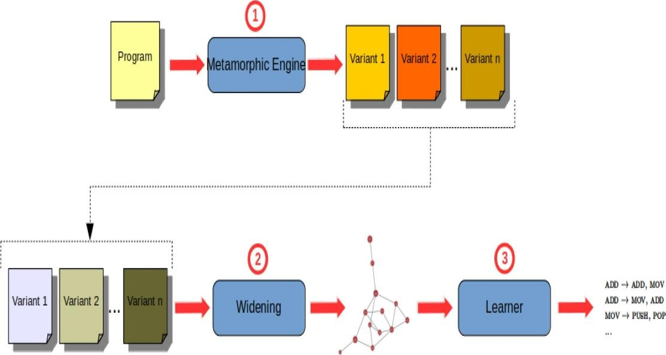

Fig. 6 : Metamorphic Malware

# Types Of Malware Analysis

While attempting to detect malware, the malware’s behavior must first be understood. Analysis would help to visualize the malware’s behavior and its tasks. There are a number of methods to reach the particular conclusion, each having its own advantages. However, the amount of time and knowledge needed to use these vary vastly. Event-driven systems can either use event loggers or hooks to track the behavior of malware. HostException Log monitoring can also be used to check the behavior of malware by reviewing the event logs regularly. There are a number of

benefits to using event-driven system to detect malware; it may affect DLL or API interception and have no or less effects on the timing of security breaches. However, a lot of time and efforts are spent on the analysis of telemetry.

These are as follows:-

## Static Analysis

Code analysis or also referred to as Static Analysis is achieved by going through the source code of the malware to determine its potential behaviour and properties. Static analysis in malware analysis involves examining the code and structure of a malicious program without executing it. This technique provides valuable insights into the characteristics and behavior of the malware, helping cybersecurity analysts identify potential threats and vulnerabilities. During static analysis, analysts dissect the code to uncover indicators of compromise, such as suspicious function calls, obfuscated strings, and hidden payloads. Additionally, static analysis can reveal the presence of known malware signatures and patterns, allowing analysts to classify the malware and understand its potential impact. By leveraging static analysis tools and techniques, cybersecurity professionals can gain a deeper understanding of the malware's capabilities and intent, enabling them to develop effective mitigation strategies and security measures. However, static analysis has its limitations, as sophisticated malware may employ techniques to evade detection, such as code obfuscation and polymorphism. Despite these challenges, static analysis remains an essential component of malware analysis, providing valuable insights into the inner workings of malicious software and helping organizations bolster their defenses against cyber threats..This reverse engineering can be achieved by one of the following ways –

## File Format Inspection

File format inspection plays a crucial role in malware analysis, offering valuable insights into the nature and characteristics of suspicious files. Metadata, in particular, serves as a treasure trove of information, providing analysts with essential details such as file type, date of creation, compile time, and functions that have been imported and exported. By examining metadata, analysts can determine the

origin and purpose of a file, helping to identify potentially malicious content. For instance, the file type can reveal whether the file is an executable, a document, or a script, providing clues about its intended functionality. The date of creation and compile time can offer insights into the timeline of the file's development, shedding light on its potential relevance and significance in the context of a security incident. Furthermore, metadata can unveil the functions that have been imported and exported within the file, providing clues about its behavior and capabilities. For example, imported functions may indicate dependencies on external libraries or system resources, while exported functions may suggest the presence of hooks or callbacks used for malicious activities. By analyzing metadata, cybersecurity analysts can gain a deeper understanding of the files under investigation, enabling them to make informed decisions about the level of risk and appropriate response actions. However, it is essential to note that metadata inspection is just one component of a comprehensive malware analysis strategy. Sophisticated malware may employ techniques to manipulate or obfuscate metadata, making it challenging to extract reliable information. Therefore, analysts must complement metadata inspection with other analysis techniques, such as dynamic analysis and code reverse engineering, to gain a comprehensive understanding of the threat landscape and effectively mitigate cyber risks.

## String Extraction

String extraction is a fundamental technique in malware analysis, crucial for deciphering the behavior and functionality of suspicious code. This method involves extracting strings from the code, including error messages, status indicators, and other textual data embedded within the malware. By analyzing these strings, analysts can glean valuable insights into the workings of the malware, infer its intended purpose, and uncover potential indicators of compromise. Error messages, for example, may reveal clues about the malware's functionality, providing insights into its behavior and potential impact on the infected system. Status indicators can also offer valuable

information, indicating the progress of specific operations or the success of certain actions performed by the malware. Additionally, strings extracted from the code may include hardcoded URLs, IP addresses, encryption keys, or command-and-control server addresses used by the malware to communicate with remote servers or execute malicious activities. By identifying and analyzing these strings, analysts can gain a deeper understanding of the malware's capabilities, command-and-control infrastructure, and potential attack vectors. Furthermore, string extraction can aid in the development of detection signatures and mitigation strategies, enabling cybersecurity professionals to better defend against emerging threats and protect sensitive systems and data. However, it's essential to note that string extraction is just one component of a comprehensive malware analysis process. Analysts must complement string analysis with other techniques, such as dynamic analysis, code reverse engineering, and behavioral analysis, to gain a holistic understanding of the malware's behavior and effectively mitigate cyber risks. By leveraging a multi- faceted approach to malware analysis, organizations can enhance their cybersecurity posture and better defend against evolving cyber threats.

## AV Scanning

AV scanning, short for antivirus scanning, is a widely employed technique in malware detection and prevention, utilized by both individual users and organizations alike. The process involves subjecting suspected files to scrutiny by antivirus software, which compares their signatures, behaviors, and characteristics against a database of known malware signatures. If a file matches a signature in the database, it is flagged as malicious and appropriate action is taken to quarantine, delete, or neutralize the threat. This method is particularly effective against well-known malware strains, as most antivirus programs maintain extensive databases of signatures for common malware variants. However, it's important to note that AV scanning is not foolproof, as it relies heavily on signature-based detection and may fail to detect zero-day threats or polymorphic malware that constantly alters its code to evade detection.

Additionally, AV scanning may produce false positives, flagging legitimate files as malicious due to similarities with known malware signatures. To mitigate these limitations, modern antivirus solutions often incorporate heuristic analysis, sandboxing, and machine learning algorithms to detect and block emerging threats based on their behavior and characteristics rather than relying solely on signature matching. Despite its limitations, AV scanning remains an essential component of a layered cybersecurity strategy, providing a critical line of defense against a wide range of known malware threats. By regularly updating antivirus databases, conducting routine scans, and supplementing AV scanning with other detection and mitigation techniques, organizations can enhance their resilience against malware attacks and safeguard their digital assets from harm.

## Disassembly

Disassembly is a fundamental technique in malware analysis, providing analysts with deep insights into the inner workings of malicious code. This method involves converting machine code, which is the binary representation of software, into assembly language, a human-readable format that represents the instructions executed by the CPU. By disassembling malware, analysts can examine the logic and functionality of the program at a granular level, allowing them to identify malicious behaviors, uncover hidden functionality, and understand the malware's attack techniques. Popular disassemblers such as IDA Pro and Ghidra provide powerful tools for analyzing executable files, offering features like interactive disassembly, graph views, and function analysis to aid in the reverse engineering process. These tools enable analysts to navigate through the disassembled code, trace the execution flow, and identify key functions and routines within the malware. Furthermore, disassembly allows analysts to uncover obfuscated or encrypted code, revealing the true intentions of the malware and providing valuable insights into its capabilities and behavior. By leveraging disassembly techniques, cybersecurity professionals can gain a deeper understanding of malware threats, develop effective detection and mitigation strategies, and enhance their

organization's overall security posture. However, it's essential to note that disassembly can be a complex and time-consuming process, requiring specialized skills and expertise in reverse engineering and assembly language programming. Additionally, malware authors often employ anti-disassembly techniques to thwart analysis efforts, making it challenging for analysts to extract meaningful information from the disassembled code. Despite these challenges, disassembly remains a critical tool in the arsenal of malware analysts, enabling them to uncover the secrets hidden within malicious software and protect against cyber threats effectively.

## Dynamic Analysis

Also known as Behavioral analysis, Dynamic Analysis is one of the most powerful techniques in malware analysis that provides visibility into real-time activity exhibited by a piece of mal-ware. Dynamic analysis entails running the malware in a controlled environment (such as within a sandbox or virtual machine) and is quite different from static analysis, which does not involve execution but instead involves disassembling/assembly of file code / contents. It basically involves closely monitoring a malware’s behavior and recording all the activities in which the file indulged. With this approach, analysts can watch the malware move and learn about its function, purpose, objectives (intent) that were to harm or impinge upon the goals of a system. Dynamic analysis of the malware is helpful in assessing the spread because this type of research allows us to run the malware in a developed environment and we can observe what it does without putting our production systems at risk. Moreover, the dynamic analysis is generally times much faster than static one because it gives instant results to the analysts about malware behavior and assess whether it is dangerous or not. Moreover, from the perspective of dynamic analysis, malware can present new and unknown behaviors that let analysts know them better and learn to detect new threats for creating countermeasures. Altogether, dynamic analysis represents an essential aspect of malware identification and prevention that gives cybersecurity pros a front- row seat to see how such threats really act in the wild and helps organizations block today’s increasingly sophisticated attackers.

## Hybrid Analysis

Hybridizing analysis is a one-size-fits-all way of dealing with malware — it allows us to leverage the most useful features that both static and dynamic bring into the table, aiding towards gaining better insight into malicious software. During the early steps of hybrid analysis, relevant signatures and features of the malware are closely looked at using static/dynamic approaches. This includes taking apart the code, examining the metadata and obfuscation techniques or similarities to known patterns (indicators of compromise). “An analyst, using static analysis, can find these known threats and identify this particular malware according to the set of established criteria.”

Static analysis is followed by dynamic analysis which gives a deeper insight into malware’s behaviour and potential when executed in a controlled manner In this way the malware can be run in a sandbox or virtual machine and its behavior and interaction with the system are monitored on-the-fly by these analysts. Exercises about Dynamic analysis reveals the behavior of malware’s execution, network activity, file system changes, and any other unusual behaviors or anomalies.

Hybrid analysis provides a broader view of the malware’s properties, capabilities, and purpose by marrying static with dynamic approaches. While static analysis can be used to identify known threats and form a base understanding of the malware, dynamic behavior will catch anything unexpected or new such as behaviors such as any attempts at evasion. It’s this combination that allows cybersecurity experts to detect, analyze and respond to increasingly complex and shifting malware threats.

Furthermore, hybrid analysis can improve the efficiency and effectiveness of malware analysis by combining the strengths of both static and dynamic approaches. Static analysis, in comparison is fast and scalable, but does not afford a more contextual view to the malwares behaviour. When combined, these two paradigms enable organizations to build stronger cyber security strategies and defenses against more advanced cyber threats through hybrid analysis.

# Types Of Malware Detection

Identifying and recognizing malevolent software virus in a computer system or network is known as malware detection. Malware can take many forms including a virus, worm, Trojans. ransomware, spyware adware and many more. The goal of malware detection is to recognize and eliminate malware’s undesirable effects with the help of maintaining the priority, revelationality, and attachments in computer systems and information. Malware detection falls under the larger umbrella of cybersecurity and includes everything from processes to technologies that are developed specifically for identifying or handling the family of malicious software programs known as malware on computing systems. "Malware comes in many shapes and sizes — it’s made up of varying types of threats, including viruses, worms, Trojans, ransomware and spyware to name a few," the agency noted. The purpose of malware detection is to; protect computer systems and data against integrity, confidentiality, and availability threats by detecting malware before causing any harm. "That means using a combination of tools, such as antivirus software, intrusion detection systems (IDS), or endpoint protection platforms to constantly be on the lookout for any indicators of compromise and anything that seems out-of-the- ordinary," he says. In addition, advanced threat intelligence as well as machine learning algorithms are being used more and more for the detection of emergent malware threats to enable malware identification in real time. Robust measures to detect malware can be a savior for any organization as it protects the organization by detecting potential cyber threats and doubles its defense mechanism by ensuring minimal risks and securitization of digital wealth maintenance.

Different types of they are as follows :-

## Signature Based Detection

The signature based detection (fig. 7), the traditional technique, is an easy and efficient manner to detect all of the known malware [16] This technique extracts a unique short sequence/pattern of bytes after malware identification to distinguish the detriment program as compared with the benign programs [17]. Signature-Based Detection (Definition: Detects known malware on identification of similar patterns /

signature based) It’s a most common practice used in cyber-security. This involved looking for signatures in files, applications or network traffic- The antivirus software and intrusion detection systems looked to match the identified malware variations. In most cases, these signatures are comprised of one or more bytes or sequences of codes and can also be compiled by behavior that resembles the known malicious component. Once a match is found, the software can react by quarantining or deleting the infected file, blocking network communication from specific IP addresses or warning system administrators. Despite the fact, that a signature-based detection can do well in recognizing and blocking all known threats, it certainly has its limitations. In terms of zero-day attacks or polymorphic malware Showing that it changes code or behavior upon infection so as to compromise defense mechanisms validation results nonzero ones reinforcement, this approach cannot always trace them back. One other drawback of a signature database is that it always has to be updated to keep the latest malware strains. Signature databases need regular updates and can become vulnerable if not updated regularly too since new threats could arise. Nevertheless, signature- based detection continues to be a building-block of any cybersecurity defense layer and is mandatory to counteract the long tail of existing malware that exists on the

world.

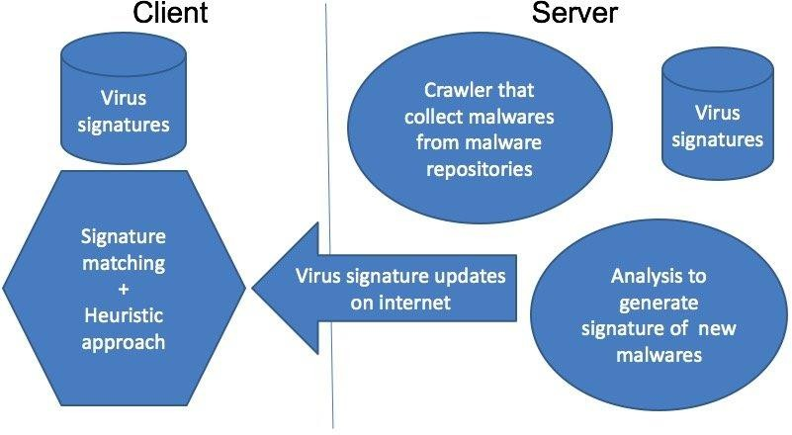

Fig. 7 : Traditional Detection System

## Heuristics Based Detection

cisomethingxperience from 2000 to 2010 heuristic-based detection technique along with signature-based detection was a significant mechanism for malware mitigation, and the promising method in Heuristic one to detect novel/unseen malwares ever before. [18]. This is an approach of two methods used in identfication. The first method is static where the suspicious programs are examined in such a way so as to get proper pattern of occurrence or any other sort if it and then checking whether the produced result goes beyond threshold, declaring that file infected (Cheng et al., 2014) [19]. B. Hybrid Heuristic, Signature based detection: In this period (between 2000-2010), besides signature-based method of detecting threats hacking techniques four were mainly deterred by the heuristic assessment on malware pathogens. Heuristic techniques seemed to be the best method for identifying new or unseen malware threats, bridging the gaps that existed with signature-based tools. This method uses two main schemes; However, static methods refer to a process in which such suspicious program’s code is analysed for defined patterns within the structure of the program If any irregular things or suspicious patterns are identified on the file, and it crosses a certain predefined threshold value, then that file is marked as possibly infected. The advantage of this type of static analysis is that cybersecurity systems can still recognize specific common characteristics or behaviour patterns exhibited by a malware, even if its detail signature remains unknown and not deployed within the databases. Applying these heuristic approaches can help cybersecurity analysts improve their malware detection and response capabilities, making it harder for the attackers to pull off malicious activities in the midst of bolder cyberattacks. On the one hand, heuristic detection is an aid in the identification of unknown malware variants, but on there other hand it possible to be umuseful. It can operate false- positive or skip complex threats that are basically not determined by listing, through for example obfuscation or polymorphism. As a result, the typical strategy tends to be more balanced—relying on both heuristic and signature-based detection methods in order to adequately defend against the variety of malware threats out there.

## Malware Normalization

The advances of such sophistication, malware authors have implemented automated advanced malware generation toolkits [20] where it uses highly sophisticated obfuscation techniques (e.g. Zeus, Ultimate Packer for Executable and Mitsfall). these kits can create malware in the order of couple thousand a day which is literally 8 impossible to catch through Signature or hurestic based malware detection

techniques. Obtain normalize executable/ malware from such method : After removing the obfuscation in a given program, this is effective to improve an existing antimalware of higher detection accuracy (Fig. 8) [21]. Since furthermore in the fight against such obfuscation techniques more and malware developer can use automated advanced malware generation tool kits, like for example zeus, ultimate packer for executable or mitsfall it has become very important to normalize malware. Once deployed, these toolkits provide attackers with the ability to quickly create tens-to- hundreds of thousands unique malware variations in a day – each one seemingly different enough to bypass traditional signature or heuristic-based malware detection methods. Consequently, malware normalization attempts to mitigate this explosion of obfuscated malware by removing the layers of obfuscation wrapping the malicious code. Analyzing the executable files or malware samples in this form will allow analysts to sidestep such obfuscation and obtain an understanding of their structure and functionality by normalizing them. Subsequently, this normalized form of the malware can be used to improve detection performance in currently installed antimalware offerings. Analysing nvmd samples, ctsec workers can create stronger signatures by attaining a better understanding of the many facets involved in crafting an effective NVT, thereby enhancing their defenses against advanced cyber threats. “Moreover, for superior disruptive action which can be take against adversaries directly or building proactive strategies, malware normalizations gives more help to security researchers to understand the adversary tactics techniques and procedures being used along with associated preparedness return,” said Malviya. However, malware normalization remains a highly useful approach to strengthen cybersecurity defenses and prepare for any cyber warfare scenario in the constantly developing field of cyberspace combat when facing automated malware generation toolkits.

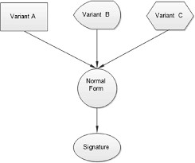

Fig. 8 : Malware Normalization

## Machine/Deep Learning Techniques

Presently, various machine learning [22] techniques are being employed to identify this zero-day malware or the one that is not seen before. “With this technique we can detect not only the known malware but also unknown malware, because it’s learning from previous detections,” Quieti explained. The process is a two-step technique, in step 1 the feature (such as API Calls, N-gram, Strings, Opcodes, Control flow Graph etc.) are to be extracted from the know datasets that leads not only for properly modeling the target concept but also facilitate the learning and classification/detection process. Afterward, in step 2, suitable machine learning algorithms (e.g., Decision Tree [23], Naive Bayes [24] Data Mining [25], Hidden Markov Modes [26], Neural Networks) were scanned for the model that can be employed to detector classify malware. The adoption of machine learning for malware detection has grown exponentially, as it enables the discovery of both known and new previously unseen types. "It builds on what we've learned from detecting previous malware to create models that can easily identify new strains." Normally, this is a two-step process: Features are then extracted from these known datasets (e.g. API calls, N-grams, strings) and opcodes/CFGs These features are responsible for defining the target concept and help accelerate both learning and classification. Detection and Classification of Malware: In second dove different machine learning algorithms are applied for detection and classification the malware. Most commonly used ones in this scenario would be decision trees, Naive Bayes, data mining techniques, Hidden Markov Models ( HMM ), neural networks etc. By feeding these features into models

and training them, the algorithms are able to make predictions about other data that is similar based on patterns or characteristics found in each feature. "One trained, the models can analyze new samples and based on what they've seen before classify them as either benign or malicious." Machine learning has many advantages for malware detection, some of which are adaptation to unforeseen threats, high scalability capabilities which allow it to be applied over large datasets and centralize same features that can detect millions of variants instead. “All of these techniques, by learning from new data and feedback on how they perform in practice (and revising their ability to detect malware accordingly), make the detection systems more accurate and efficient over time. This helps organizations strengthen their own networks and systems against cyberattacks.”

# 1.5 Structure of the Project

While going through this project you will mainly come across these components- **Chapter 1** gives us a basic idea about the project and helps you familiarize with the necessary technical and theoretical aspects of our project.

**Chapter 2** consists of review of other journals and research papers.

**Chapter 3** tells us about the system design and various tools and techniques needed to achieve the same.

**Chapter 4** includes feasibility study which includes technical, economic, operational, legal, and market viability.

**Chapter 5** gives us a comparative study of the performance of each model making it easier for us to choose the best one most suitable for us.

**Chapter 6** provides us with the conclusion and also tell us about the future scope of our project.

# CHAPTER 2 LITERATURE REVIEW

# Background Study

But as early as 2009, Daly published research that showed the potential for planned and coordinated attacks designed to gain long-term network control within a targeted company [27]. For example, referring to Quick Heal Threat Research Lab is received over 350,000,000 malicious files which targeted tens of thousands of workstations in only the first quarter of 2016 Aimoto et al [28]. Ito et al. In May 2017, for example, Symantec revealed they had uncovered the Banswift cybercrime ring behind the theft of US $81 million from Bangladesh Bank [29]. Kid Security. However, Elasticsearch and Logstash applied incorrectly resulted in the app designed to help parents monitor their children's online safety leaking user records for more than a month. The breach was discovered by expert Bob Diachenko in mid-September, who said it impacted 300 million records (including 21,000 phone numbers and 31,000 email addresses), along with some credit card info. September Cyber news.

The primary goals of the malware detection techniques are to identify the malicious software and protect the system in which it is used, and ensure that other networks or computers linked should also be protected. For the detection and classification of malware samples, in order to entrainate such inputs properly under their respective families, they can be defined in many ways: There are many authors who have done work on this and proposed methods to recognize or categorize the malware file with their version. A detailed summary of the major research publications listed in Table 1 is provided within this publication. We have also observed the exported malware in graphical representation along with feature vectors. Note that this is fundamentally different from classifying images, where the labeling of data can be particularly simple (each image belongs to exactly one label) and its easy to get a lot of it. Instead, recognizing malware and numeric clustering into families are labor intensive tasks require expertise in the subject In another study, the authors suggested a learning technique to analyze the dangerous code and classify it according to its malware family [2]. The first step to malware family identification is grouping all portable executables (PE) and choosing the traits coincident among them. Therefore, these

features determine the specific category of malware and activities involved in defining the executable organization and suggested approach accuracy ≃99.8% [30].

## Evolution of Malware Detection Techniques

There you have it. The evolution of how we detect malware is right in line with the increasing sophistication of said, well, malware! Being an old fashioned way, Early methods of safeguard depended on signature-based detection which uses specific patterns or signatures of known malware to detect the malicious files. Although it was successful against all threats that were known at the time, this method did not fare so well with new or as yet unseen malware (zero-day attacks).

In order to overcome such limitation, heuristic-based methods were subsequently developed. These analyze the behavior of programs in fact to understand whether they could carry out actions which are typical of a malware infestation. These approaches attempt to detect suspicious activity (e.g., attempts to access system resources without the appropriate permissions, or traffic flowing in a port different from normal communication ports) by inspecting system and network characteristics. Despite being less rigid than signature scanning, heuristic approaches have the tendency to produce false positives given that well-behaved applications on occasion act like a virus or worm.

## Malware Detection using Machine Learning and AI

* Machine-learning (ML) and Artificial-intelligence (AI) have greatly improved the ability to detect and categorize malware. It does so by learning from huge datasets which contain examples of software that is both benign and malicious. This helps the technique to recognize patterns or deviations that could suggest something is malware. machine learning models such Support Vector Machines (SVM) [7], Random Forests (RF) [23] and Neural Networks (NN) have been used extensively. For instance, research has proven that models based on opcode sequences, API call patterns, and n-grams is able to classify benign and malicious software with a high success rate.

Deep Learning (a class of machine learning) has now expanded our capabilities even further Convolutional Neural Networks (CNNs), Recurrent Neural Networks, etc. Can extract features from raw data on their own and we do not have to worry about

extracting the valid features through manual effort. This approach has been particularly popular for image-based models that treat binary files as though they are just gray-scale images.

## Comparative Analysis of Research Contributions

The literature for malware detection has been diverse with numerous studies proposing novel techniques and obtaining high accuracy rates. A comparative analysis is outlined in Table 1, which points to the diversity of approaches and their respective performance measures. The feature engineering approach appears relevant, as effective feature extraction plays a significant role in achieving high-accuracy malware detection. Among the most common features are API calls, opcode sequences, and patterns of byte code. All the reviewed articles demonstrate that well- engineered features improve the performance of the model. As for algorithms, different models have distinct advantages. For instance, Random Forests and Support Vector Machines are recognized for their strength and the highest accuracy. At the same time, deep learning models such as CNN and RNN have the ability to learn to automatically extract complex features. Their weakness, however, is their inability to learn abstract models, and oversimplification may complicate the tasks. It is also apparent that hybrid models are more effective as they combine static and dynamic approaches. The static approach is using the code, that is, the appearance of the application without running it, while in the dynamic approach, the software’s activity is monitored while operating. The latter approaches are among the most effective in the respective areas, and the hybrid model has an advantage due to the combination of their traits. The rise of malware attacks has led to concerns that a single machine is insufficient to address the evolving needs. One of the ways to ensure scalability and efficiency of approach is training models using datasets and deploying them on distributed systems, ensuring the detection is accurate and timely. Although substantial progress has been observed, the field retains its appeal by addressing the challenges posed by evolving types of malware.

Adversarial attacks pose the biggest concern. These are attacks where the malware is specifically generated not to be detected. With such threats and their popularity in the current world, the researchers still need to focus on developing models that cannot be attacked so easily.

## Challenges of the Future

The other challenge is posed by the emergence of new IoT devices and cloud computing. These approaches allow attackers to develop new strategies, as the environment faces substantial changes that require new malware detection methods. Old methods need to be adapted but should be used with new and innovative methods to address the emerging threats. All in all, the field of malware detections has experienced a significant amount of progress driven by advances in machine learning and AI. The comparative analysis of the reviewed papers indicates the relevance of the feature engineering approach, the significance of the model selection of the algorithm, and the hybrid approach. With the cyber threats continuing to grow and evolve, the emphasis on these aspects cannot be underestimated.

# Comparative Analysis Of Research Papers

Given below the comparative analysis of research papers:

|  |  |  |  |
| --- | --- | --- | --- |
| **Authors** | **Inputs** | **Algorithm**  **/Techniques** | **Findings** |
| Ye et al.in (2007)[31] | Api Execution sequences | Rule based classifier | IMDS surpassed other data mining techniques and several antivirus programs with a 93% detection accuracy. |
| Shafiq et al. (2008) [32] | n-grams | HMM | The suggested technique detects malware with a TPR of 84.9% and an FPR of 16.7%. |
| Moskovitch et al. (2008) [33] | opcode features | ANN, NB, DT and  Adaboost | The model predicted the virus in the file under examination with a  considerable degree of accuracy (94.5%). |

|  |  |  |  |
| --- | --- | --- | --- |
| Griffin et al. (2009) [34] | 48 Byte string signature | 5- gram Markov Chain model | Signatures with one or more components were used to train the classifiers. Having several component signatures increased the chance of a satisfying accuracy outcome when compared to the equivalent. Less than 0.1 percent false positive rate (FPR) was achieved. |
| Nataraj et al. (2011) [35] | Gray scale  image of Binaries | KNN | demonstrates 98% classification accuracy on a collection of malwares from 25 different families. |
| Shabtai et al. (2012) [36] | 1-6 gram opcode features | Random Forest classifier, Naive Bayes, ANN, Logistic Regression, BDT, DT, and BNB | When it came to accuracy, RF, BDT, DT, G-Mean, FPR,  and TPR performed better than NB and BNB. Random Forest produced the best results with 95.14% accuracy. |
| Ravi et al. (2012) [37] | API call sequence | J4.8, IMDS, SVM,  Rule Based classifier, Naive Bayes, and SVM | The suggested solution makes use of a third-order Markov model, which operates with 90% accuracy on the testing dataset and 99.38% accuracy on the training dataset. |
| Santos et al. (2013) [38] | Frequency of opcodes | DT, KNN,  Bayesian, SVM | SVM performs better than  95.7 % for features of two opcode lengths. |
| Comar et al. (2013) [39] | Flow level features | KNN, SVM, WL, RBF | For identifying new classes, the supervised weighted linear kernel provides the best performance metric. |
| Uppal et al. (2014) [40] | N grams from API  sequences | Naive Bayes, Random Forests, SVM, and  Decision Tree | SVM produces the best results (98.5% accuracy) out of all the classifiers. |

|  |  |  |  |
| --- | --- | --- | --- |
|  |  | Classifiers |  |
| Salehi et al. (2014) [41] | API calls | RF, J48, Rotation RF, FT, and NB | 94.6% was the greatest true positive rate of any classifier used, and random forest produced the highest results. |
| Sexton et al. (2015) [42] | Byte code Sequences & opcodes | Naive Bayes, Rule Based classifier, Logistic Regression, SVM | The Markov chain approach to SVM revealed an 84.9% True Positive Rate. |
| Saxe et al. (2015) [43] | The string histogram, the byte sequence, and the 2D PE properties | Deep Feed  forward neural network | The suggested model yielded a 95% True Positive rate. |
| Narra et al. (2016) [44] | Opcode Sequence | K-means, expectation maximization with  HMM, SVM | The model operates with a 98% accuracy rate. |
| Ahmadi et al. (2016) [45] | Hex dump based features | XGBoost classification algorithm | A 99.8% detection accuracy was provided by the suggested model. |
| Kolosnjaji et al. (2016) [46] | System call sequences | Convolutional & Recurrent Neural Network | The average accuracy and recall of the combined model were 85.6% and 89.4%, respectively. |
| Narayanan et al. in (2016)  [47] | Image of Polymorphi c Malware file | KNN, ANN, and SVM | Over the others, linear KNN provided an accuracy of 96.6%. |
| Nikolopoulos and Polenakis (2017) [48] | ScD graph created using system calls | SaMesimilarity and NP-similarity metrics | The suggested model has a detection rate of 83.42%. |

|  |  |  |  |
| --- | --- | --- | --- |
| Zhixing Xu et al. (2017) [49] | systemcalls for memory access | logistic regression and random forest classifier | The random forest classifier performed better, with a true positive rate of 99%. |
| Raff et al. (2017) [50] | PE header features | LSTM, Random Forests, LR, ET | An accurate network with all connections made and calibrations made may reach 93.3%. |
| Kotov et al. (2018) [51] | Windows API calls | Symbolic execution & HMM models | With an accuracy rate of 87.6%, the top prediction model detects malware. |
| Le et  al.(2018) [52] | Gray scale  image of binary malware file | Convolutional Neural Network | Using 10568 binary data to train the classifier, the accuracy rate was 98.5%. |
| Nguyen et al. (2018) [53] | Image based representati on of lazy binding CFG | CNN | CNN produced an accuracy of 98.87%. |
| Krcal et al. (2018) [54] | PE, API calls | MalConv, CNN, FNN | At 96.4% accuracy, the suggested convolution network outperforms other models. |
| Ni et al. (2018) [55] | Gray images based on Sim hash | Hashing & CNN | The average accuracy of classification attained was 98.86%. |
| Rathore et al. (2019) [56] | Opcode Features | RF, DNN with 2, & 7 Hidden Layers | RF outperforms DNN with a 99.6% accuracy rate. |
| O. Suciu et al. (2019) [57] | PE header features | FGSM | The suggested method shows that forceful assaults on mode are effective. This does not provide efficient models when trained on small datasets. |

|  |  |  |  |
| --- | --- | --- | --- |
| Yuxin et al., in (2019) [58] | n-gram | Deep Belief Network | When trained on unlabeled data, DBN outperformed KNN, SVM, and Decision Trees in terms of classification accuracy. |
| Rabbani et al . (2020) [59] | protocols, jitters, IP addresses, TCP, and UDP | PSO with PNN | With 96.5% accuracy, the model was able to identify malicious behavior. |
| Yucel et al. (2020) [60] | Memory Image of Exe file | Virtual machines & 3D Imaging | Using an average of 0.886, the authors' research looked at the similarity rates across many malware families. A few succeeded in reaching a  99.5 percent accuracy rate. |
| Vasan et al. (2021)[61] | Windows executables, system call sequences | Unsupervised anomaly detection using Isolation Forest | displayed the potential of unsupervised learning for malware detection by achieving high accuracy in identifying previously unknown malware types. |
| umar et al. (2022)[62] | Android APK files, API calls, permissions | Hybrid model combining static and dynamic analysis using RNN | Detected malware with 98.7% accuracy, highlighting the effectiveness of hybrid approaches for Android malware detection. |
| Gibert et al. (2023)[63] | PE files, opcode sequences | LightGBM, CNN with attention mechanism | Achieved 99.4% accuracy in malware detection, outperforming other ML algorithms. Attention mechanism improved model interpretability. |

Table 1 : Comparative Analysis of Research Paper

# CHAPTER 3 SYSTEM ANALYSIS

Actually, the model we can say that it is being followed currently-in use the phase in WATER FALL MODEL assumes to be arranged in well-defined linear sequence. 1. First of all, the feasibility study is done 1. Once that is done now requirement gathering and project planning are the next phases. If the system exists one and modification and addition of new module is necessary, least analysis for present system may be taken as basic model. It is done after the requirement analysis and before the coding phase. Coding does not start until designing being completed. After the coding the next phase of software development life cycle is testing. In this particular model, there is a sequence of activities that are performed in the software development project:-

* + - * Requirement
      * Project Planning
      * System design
      * Detail design
      * Coding
      * Unit testing
      * System integration & testing

But, the important part is that these activities are to be linear ordered.At the end of the phase and output of one phase is input of other phase. The output of each phase should be such that in case the whole is formed, it fulfills the system’s overall requirement. - Few of the feature of 6 - spiral model is also included as after completing each of the phase only than work done by all those stakeholder who are involve in with that project. As all the requirements were previously known to us and our software is made with the objective of computerizing/automating a pre-existing manual working system, we have chosen WATER FALL MODEL.

# Tools and Technology Requirements

We have used many Tools and technologies used for our project and all are discussed here –

# Python

**Simple and Readable Syntax:** Python's syntax is designed to be simple and easy to read, making it an ideal language for beginners and experienced developers alike. Its clean and straightforward syntax emphasizes readability and reduces the cost of program maintenance.

**Interpreted Language:** Python is an interpreted language, meaning that code is executed line by line, making it easy to debug and test. This also allows for rapid development and prototyping, as changes can be made quickly without the need for compilation.

**High-level Language:** Python is a high-level language, which means it abstracts away many low-level details like memory management and pointer manipulation, allowing developers to focus on solving problems rather than dealing with system- level intricacies.

**Dynamic Typing:** Python is dynamically typed, meaning that variable types are determined at runtime rather than at compile time. This provides flexibility and allows for more concise code, but can also lead to potential runtime errors if not handled carefully.

**Rich Standard Library:** Python comes with a comprehensive standard library that includes modules and packages for a wide range of tasks, from web development and data manipulation to networking and GUI programming. This extensive library reduces the need for developers to write code from scratch, speeding up development time.



Fig. 9 : Python

# Google Colab

It’s a free tool for writing and running Python right in your browser.

* + - * **Real-time, collaborative:** In true wiki form, multiple people can work on a document in real time (you already do this with Google Docs) granted access rights prevent conflicts
      * **Pre-installed Libraries:** Commonly used Python libraries in the field of data science and machine learning are already installed so that one doesn’t waste any time in using them.
      * **GPU and TPU Support:** You get to use powerful GPUs with TPUs for free, if you need it to speed up your calculations ( very handful in machine learning projects)
      * **Google Drive integration:** It saves you work. It allows you to easily share the content with it's integration with Google Drive.
      * **Markdown Support:** Add formatted text and math equations using Markdown and LaTeX to your notebooks, for a smoother experience in organizing and presenting your work
      * **Accessibility:** Basically, it is easily accessible and free of charge (if you don’t use an extensive allocation of resources).
      * **No Setup:** There is nothing to install on your computer. You just need to login with your google account and you can start coding straight away and run code cells (useful when you want to run one by one in the serial order, best approach for debugging)



Fig. 10 : Google Colab

# Pycharm

It's a powerful integrated development environment (IDE) specifically designed for Python development, created by JetBrains.

* + - * **Smart Code Editor:** Provides intelligent code completion, real-time error checking, and quick fixes, making coding faster and easier.
      * **Debugging Tools:** Includes advanced debugging features like breakpoints, step-by-step execution, and a visual debugger to help troubleshoot code.
      * **Version Control Integration:** Supports version control systems like Git, SVN, and Mercurial, allowing you to manage your code changes efficiently.
      * **Refactoring:** Offers powerful refactoring tools to help you clean up and improve your code, ensuring it remains maintainable and scalable.
      * **Web Development Support:** Comes with support for popular web frameworks like Django, Flask, and Pyramid, making it ideal for web development.
      * **Database Tools:** Includes built-in tools for connecting to and managing databases, allowing you to interact with databases directly from the IDE.
      * **Customizable and Extensible:** You can customize the IDE with various plugins and themes to fit your workflow and preferences.
      * **Cross-Platform:** Available for Windows, macOS, and Linux, ensuring you can work on any operating system.
      * **Professional and Community Editions:** Offers a free Community Edition with essential features and a paid Professional Edition with additional tools and capabilities for advanced users.



Fig. 11: Pycharm

# Pandas

It is a data manipulation and analysis library for Python. pandas is an open-source, BSD-licensed library providing high-performance, easy-to-use data structures and data analysis tools for the Python programming.

* + - * **Data Structures:** It provides 2 main data structures namely Series (1 dimensional) and DataFrame(2dimensional), which are of a very effective, optimized form to perform various operations on the dataset.
      * **Data Handling:** Helps in easy data missing values imputation, cleaning datasets and making complex transformations on the dataset.
      * **Data Import/Export:** Read and Write from different file formats such as CSV, Excel, SQL Databases,etc.
      * **Data Analysis:** It is the powerful features of spreading, filtering, & grouping make data analysis easier than ever.
      * **Time Series Analysis:** which supports time series data and proffers adept functionality for date and time manipulation.
      * **Interoperability:** Can be easily integrated with other python libraries (e.g. NumPy, Matplotlib, scikit-learn), which makes the language a more suitable tool for data science purposes
      * **Performance:** It is designed to be performant with highly optimized algorithms, so it works well for processing data over big numbers of records.
      * **Communitypowered:** With a huge community, this gives you plenty of documentation how to’s tutorials help and forums for whatever algorithms have perplexed you.
      * **Versatility:** It is widely appreciated and used in different domains, including but not limited to finance, economics, statistics, data science (academically or industrially)



Fig. 12 : Pandas

# Numpy

A fundamental package for array and matrix computing with python.

* + - * **Powerful N-dimensional arrays object:** Almost NumPy is a general-purpose array with fast facilities to operate on it.
      * **Mathematical functions:** Example of these functions include- you can use a set of mathematical function to do any kind of operation with vectors or matrices, linear algebra, statistics or Fourier transformations as well.
      * **Performance:** Lightning fast numerical computations, which are simply not possible with Python’s built-in lists.
      * **Element-Wise Operations:** This helps to support element-wise operations like addition, subtraction etc. on the arrays which results in straightforward usage and ‘the entire dataset computation’ at a time.
      * **Integration:** It perfectly integrates with other scientific libraries in Python (for instance, pandas, SciPy or Matplotlib) to achieve even more effective capabilities.
      * **Broadcasting:** It is used to perform operations on arrays of different shapes and sizes, which simplifies coding.
      * **Memory Efficiency:** It is designed to be memory efficient i.e it tries to reduce the overhead which comes with numerical computations.
      * **Community and Documentation:** Has a strong community and is well- documented, which means learning how to use it as well as troubleshooting any issue becomes easier.
      * **High Performance:** Computation can be offloaded from Python to libraries written in other languages (e.g., C, Fortran).



Fig. 13 : Numpy

# Scikit-Learn

It's a popular open-source machine learning library in Python that provides simple and efficient tools for data analysis and modeling.

* + - **Wide Range of Algorithms:** Includes a variety of machine learning algorithms for tasks like classification, regression, clustering, and dimensionality reduction.
    - **Ease of Use:** Designed to be easy to use, with a consistent interface for different algorithms, making it accessible for both beginners and experts.
    - **Built on NumPy and SciPy:** Integrates well with NumPy and SciPy, ensuring fast and efficient numerical computations.
    - **Model Selection:** Offers tools for model selection and evaluation, including cross-validation, grid search, and metrics to assess model performance.
    - **Preprocessing:** Provides various preprocessing techniques to prepare data for modeling, such as scaling, normalization, and encoding categorical variables.
    - **Feature Engineering:** Supports feature extraction and selection to improve model accuracy and performance.
    - **Community Support:** Backed by a strong community and comprehensive documentation, with many tutorials and examples available.
    - **Interoperability:** Works well with other data science libraries like pandas and Matplotlib, making it easy to integrate into your data analysis workflow.
    - **Versatile Applications:** Used in various fields, including finance, healthcare, marketing, and more, for tasks like predictive modeling, customer segmentation, and recommendation systems.



Fig.14 : Scikit-Learn

# CHAPTER 4 FEASIBILITY STUDY

In this context, the ambition to determine the technical feasibility but also the economic, operational and legal capacity for implementing an all-encompassing framework that would link software performance evaluation and malware detection into a single system. This study gathers these details in what will be considered here as secondary information. This framework will help to meet this increased need for a holistic solution that can provide system health monitoring of the ever complex software and control system landscape as well as the increasing sophistication of cyber threats.

# Technical Feasibility

We have critically analyzed the technical feasibility of the proposed framework, including necessary technologies and tools’ to what extent can be accessed, integration with existing systems or interoperability requirements; scalability and adaptability demands, as well as experience within the project team.

**Technologies and Tools:** The necessary technologies and tools to implement the framework, including performance monitoring solutions, malware detection algorithms or data analytics platforms are available in the industry as established standards. Here, we can assure that the project team cannot make use of any other components for integrating a framework.

**Integration and Interoperability:** The framework will be structured on a set of well- defined interfaces and protocols that allow the performance evaluation, malware detection modules to integrate directly with each other seamlessly. “This in turn will allow for more effective data exchange and the creation of an holistic view of system health, breaking through current market fragmentation.”

**Scalability and Adaptability :** The framework is to be architected in such a way that it can scale up to accommodate the increasing complexity of software systems, and growths changes in cyber-attack landscape. Adaptability to future needs can be broadened by using modular design and incorporating cloud-based or distributed

computing among others which will ensure ease of reusablility in a manner that the framework remains effective over time.

**Expertise & Resources** : The project team will consist of subject matter experts on software engineering, performance engineering, cyber security, and data analytics. As a result, the capability to effectively build and implement this full-bodied framework.

# Economical Feasibility

While contemplating cost-benefit analysis, pricing and revenue model, and funding/investment opportunities; yeast introduced economic feasibility has been undertaken.

**Cost-effective:** In conclusion, the cost for this full-fledged framework will offer remarkable money due to its decreased data leakage preventing system downtime and compliance breach probability. The performance improvements and increased security posture are anticipated to offset the cost of implementing and maintaining either system.

**Pricing and Revenue Model:** The framework can be offered to the organizations either through subscription based service or licensed software. It can have flexible pricing depending on the requirement of target organization at different scales This flexible model will help make the framework available to a large number of customers, while also resulting in an ongoing revenue stream for the project.

**Funding and Investment:** This project can receive funding from a combination of internal R&D budgets, government grants, as well as venture capital investments due to high demand in the espionage market swathes of other strategic importance.

# Operational Feasibility

Finally, the operational feasibility of the framework was considered with respect to organizational readiness, training and support, as well as maintenance and update considerations.

**Organizational Readiness:** The framework will ensure the designed solution will seamlessly be implemented with the existing IT infrastructure and security practice without impacting ongoing operation to comfort maximum user adoption among stakeholders.

**Training and Support**: It will offer extensive user documentation, training schedules, and exclusive technical support for the ease of implementation and application of the framework across target stakeholders.

**Maintenance and Updates:** The framework must define automatic processes to update the automated detection signatures, performance optimization algorithm, etc regularly so that it can be maintained over time.

# Legal And Regulatory Feasibility

The legal and regulatory feasibility of the framework has been evaluated. It explicitly emphasized compliance with industry standards regulation, data privacy and security, or intellectual property rights underage.

**Complying with industry standards and regulations:** Framework will be designed considering all the relevant industry standard like NIST SP 800-series, and make it compliant as per data privacy and security regulation such as GDPR, HIPAA, PCI DSS etc.

**Data Privacy and Security:** The framework’s data processed would be subjected to robust measures that ensure protection of the confidentiality, integrity through encryption, access controls and audit logging.

**Intellectual property:** Our project team will make sure that this framework’s design and implementation does not violate any potential patents or copyrights, they are going to think about filing for patent protection of those innovative components of the given framework.

# Market Feasibility

All the presented dimensions in terms of Market Feasibility (i.e., Target market and customer segments, a competitive advantage, partnerships/strategic alliances) have been examined regarding the overall framework.

**Target Market and Customer Segments:** The framework is targeting organizations that operate within the IT, financial sector, health care among critical infrastructure industries. Screening will be compulsory in infected facilities.

**Competitive analysis:** A competitive analysis for this framework will illustrate clear differentiation from existing solutions based on an integrated, scalable and adaptive approach to system health management designed specifically to met the needs of the intended target market.

**Partnerships and Strategic Alliances**: The Project Team will consider partnering with one or more leading technology vendors, security solution providers, and industry associations to increase the market penetration and credibility of the framework.

# CHAPTER 5 METHODOLOGY

For detecting malware, machine learning method with one-sided perceptron will be used. It will be applied on the required dataset for detecting malware from different files present in the systems.

# Overview of the Methodology

The required methodology will use various machine learning algorithms to solve out the problem of malware in the computer systems in the form of files. These algorithms will be applied by designing a database according to the dataset. After this, analysis and design is performed on the required dataset.

# Implementation

As per our ongoing discussion, some of the security threats and challenges faced by the digital world have been discussed in depth. Keeping them in mind we will go with a static analysis method for achieving the desired outcome

## Pseudo Code for Converting PE files to CSV files:

*IMPORT NECESSARY LIBRARIES*

**DEF RUNALGORITHM():**

*# GET THE FOLDER PATH FROM THE USER*

FOLDER_PATH = INPUT("ENTER THE FOLDER PATH: ")

*# GET ALL THE FILES IN THE FOLDER*

FILES = OS.LISTDIR(FOLDER_PATH)

*# CREATE A LIST TO STORE THE MALICIOUS FILE PATHS*

MALICIOUS_FILES = []

*# ITERATE OVER EACH FILE IN THE FOLDER*

FOR FILE IN FILES:

*# CHECK IF THE FILE IS A PE FILE*

IF IS_PE_FILE(FILE):

*# EXTRACT FEATURES FROM THE PE FILE*

FEATURES = EXTRACT_FEATURES(FILE)

*# CHECK IF THE FEATURES INDICATE THAT THE FILE IS*

*MALICIOUS*

IF IS_MALICIOUS(FEATURES):

*# ADD THE FILE PATH TO THE MALICIOUS FILES LIST*

MALICIOUS_FILES.APPEND(OS.PATH.JOIN(FOLDER_PATH,

FILE))

*# RETURN THE LIST OF MALICIOUS FILES*

RETURN MALICIOUS_FILES

## DEF EXTRACTFEATURE():

*# GET THE PE FILE PATH FROM THE USER* PE_FILE_PATH = INPUT("ENTER THE PE FILE PATH: ") *# EXTRACT FEATURES FROM THE PE FILE*

FEATURES = EXTRACT_FEATURES(PE_FILE_PATH)

*# RETURN THE FEATURES*

RETURN FEATURES

## DEF BTOCSVALGORITHM():

*# GET THE MALICIOUS FILE PATHS FROM THE USER* MALICIOUS_FILE_PATHS = INPUT("ENTER THE MALICIOUS FILE PATHS: ")

*# CONVERT THE MALICIOUS FILE PATHS TO A LIST* MALICIOUS_FILE_PATHS = MALICIOUS_FILE_PATHS.SPLIT(",") *# CREATE A LIST TO STORE THE CSV DATA*

CSV_DATA = []

*# ITERATE OVER EACH MALICIOUS FILE PATH*

FOR FILE_PATH IN MALICIOUS_FILE_PATHS:

*# EXTRACT FEATURES FROM THE PE FILE*

FEATURES = EXTRACT_FEATURES(FILE_PATH)

*# CREATE A CSV ROW FROM THE FEATURES*

CSV_ROW = FEATURES_TO_CSV_ROW(FEATURES)

*# ADD THE CSV ROW TO THE CSV DATA LIST*

CSV_DATA.APPEND(CSV_ROW)

*# SAVE THE CSV DATA TO A FILE*

SAVE_CSV_DATA(CSV_DATA)

Table 2: Pseudo Code for Conversion of PE Files to CSV Files

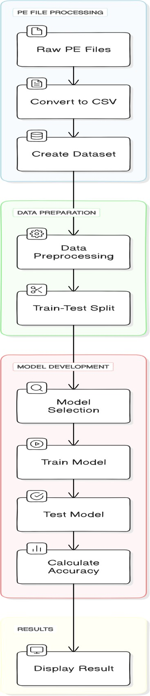

Fig. 15: Flow Chart of the Proposed System

# Preparing the DataSet

## Data Collection

The data collection process for malware detection typically involves gathering samples from diverse sources, including malware repositories, security research publications, and real-world incidents. Samples encompass various malware types and strains, providing a comprehensive dataset for analysis. These collected specimens are meticulously curated to ensure representativeness and relevance to current cybersecurity threats. Metadata attributes such as file properties, behavioral patterns, and code signatures are extracted from the samples to form a feature-rich dataset. This process adheres to academic rigor, employing stringent methodologies to assemble a diverse and representative corpus essential for robust research and development in malware detection systems. In the project we took the dataset from Kaggle.

## Feature Extraction

Feature extraction in malware detection involves systematically extracting pertinent attributes from collected malware samples for subsequent analysis. This process encompasses the identification and extraction of diverse features, including file characteristics such as size, type, and entropy, as well as behavioral patterns such as system calls, network traffic, and file interactions. Code-level attributes such as API calls, opcode sequences, and function call graphs are also extracted to provide deeper insights into malware behavior and functionality. The feature extraction process adheres to academic standards, employing rigorous methodologies to ensure the integrity, relevance, and representativeness of the extracted features, facilitating accurate and effective classification of malware instances.

Our Dataset contains 58 features

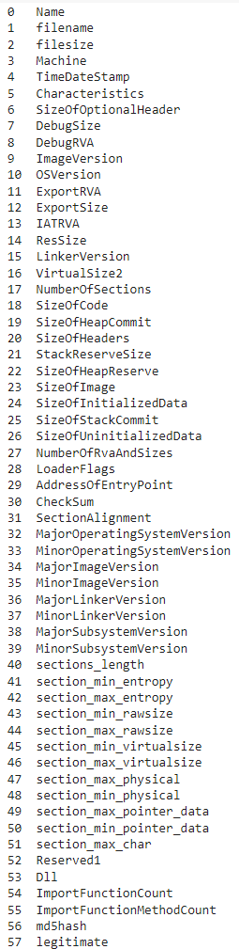

Fig 16: Features of the dataset

## Organizing Datasets

After importing the data and extracting the features, we organize the dataset into legitimate and malware

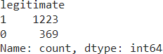

Fig. 17: Organizing Dataset

## Feature Selection

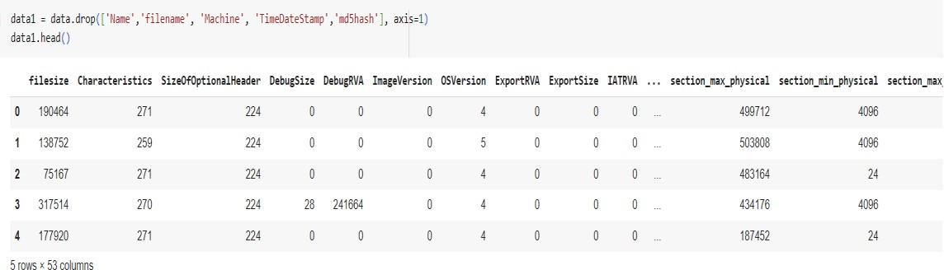After organizing and dividing the dataset, we move towards selecting the most important features from our dataset. The dataset consists of 58 features but not all will be of that much importance. So we use tree based feature selection to assign weight to features and select the most important ones out from the 58 features.

Fig 18: Feature Selection

From the above output image we can see that out of the total 53 features ( removing the name, Filename, md5hash,Machine and TimeDateStamp column as they are not necessary in our scenario) only 14 were important and selected using the tree based feature selection. We can also see the features selected and the weight assigned to each one of them(Fig. 19).

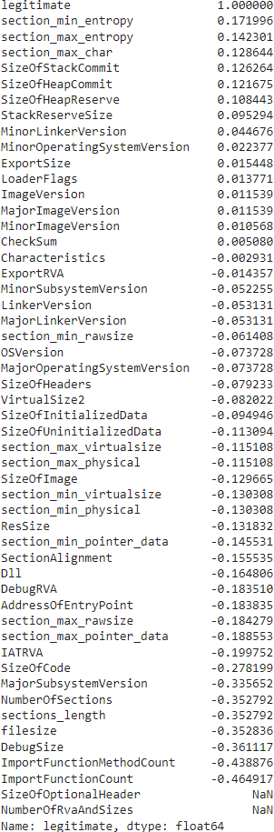

Fig. 19: Weight of Different Features

## Splitting the DataSet

After feature selection we move towards splitting the dataset into training and testing sets. We can divide the dataset into any ration but here we go with the 70:30 ratio i.e. 70% training size and 30% test size.

Fig. 20: Splitting DataSet Size

* + 1. **Learning Algorithims and Their Performance**

In order to compare and analyze the performance of our algorithms we take the use of confusion matrix and also take into consideration the accuracy of each algorithm.

Different Algorithim used in the project are:

## Linear Regression

Linear Regression is a basic supervised machine learning algorithm under regression analysis, that establishes the relationship between (one or more independent) the dependent and one or more independent variables. This modelura assumes that the relationship between input and output variable is linear To do this, the algorithm tries to ‘fit’ a line that ‘best represents all these points’ in high dimensional space.

At its most basic level, linear regression does this by finding the coefficients (slope and intercept) of a linear equation that has an error that is minimized to the actual/predicted target variable values. The most common way to do this is by least squares, which minimizes the sum of squared differences between observed values and predicted values.

In training, the algorithm iteratively changes/adjusts these coefficients repeatedly with techniques like gradient descent until the model performance is optimal or it converges. Once fitted, a new vlaue of the target can be predicted approaching with known values of the features by multiplied them for coefficients learned:

There are several use cases of linear regression not limited to the fields of finance, economics, and engineering. People can perform different tasks like predicting stock prices, estimating demand for a product in long-term or short-term intervals, analyzing the impact of independent variables on dependent variable etc using liner regression model. Although it seems so easy, linear regression is the building block of more powerful regression models and should always be one of the main tools in your basket.

Here is accuracy after successful implementation in given figure:

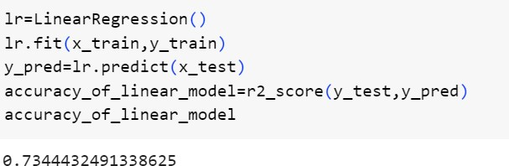

Fig. 21: Linear Regression

## XGBoost

XGBoost stands for eXtreme Gradient Boosting. It is differentiated as an advanced implementation of gradient boosted decision trees designed for speed and performance, which has proven to be one of the most effective algorithms available today (in the supervised learning domain). While traditional gradient boosting serially adds a weak learner to improve model performance using the steps above, XGBoost uses an optimized and more regularized form of gradient descent presented below.

XGBoost From Scratch XGboost forms an ensemble of decision trees where each tree is built to correct the errors of its predecessors. At the core of the process lies an iterative approach where a loss function is optimized by sequentially adding trees to myriad trees and ensuring each tree focuses on residuals or errors from past mistakes. Some other techniques used to avoid overfitting and increase the generalization are shrinkage (learning rate) and tree pruning.

Moreover, XGBoost also integrate additional feature like column subsampling and row subsampling(bootstrap aggreagtion) to improve both model robustness and at the same time, addresses scalability. The API also allows to provide support for custom loss functions and evaluation metrics thus making the library highly configurable for different use cases.

Because of XGBoost’s well-written algorithm, implementation, scalability and flexibility it has enabled very efficient solutions ( not only to Machine learning competitions ) but also in a variety of real world problems across industries. As all of

this allows it to provide cutting edge performance in the most computationally efficient manner possible, AdaBoost is without a doubt one of the best and most widely used ensemble learning techniques by data scientists and machine learning practitioners out there.

Here is accuracy and Confusion Matrix after successful implementation in given figure:

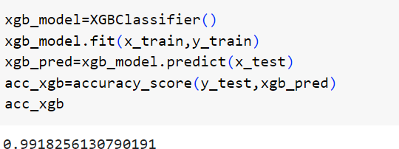

Fig. 22: XGBoost

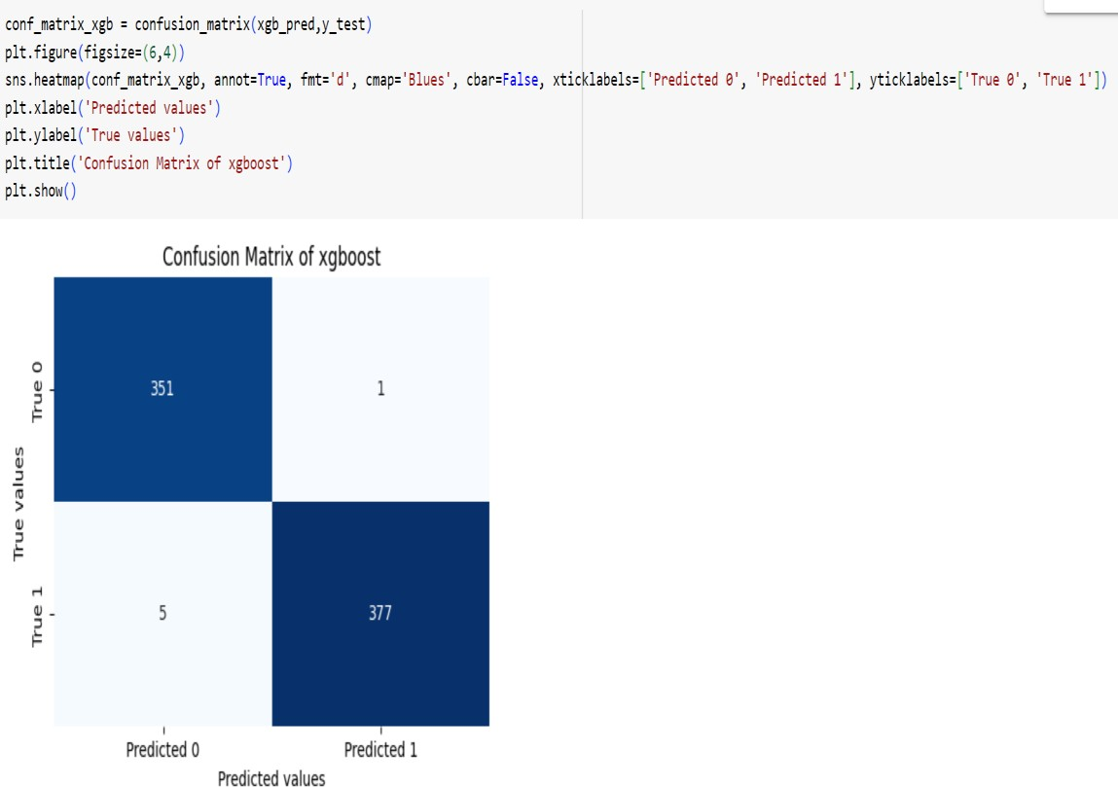

Fig.23 Confusion Matrix of XGBoost

## Decision Tree

Decision Tree is powerful and instinctive machine learning algorithm which can be used for classification as well regression purposes. We'll avoid going too much into

the details of how a decision tree works, but in short it is a algorithm which constructs its model by dividing the input feature space recursively into smaller subspaces while having every point correctly classified. as you may have visualized this forms a pottery and looks like our maze!

The algorithm is trained with different features and at every node it chooses the best feature. It also picks the optimal split point for that feature using some criterion (e.g. Gini impurity, mean squared error). This is done recursively all the way down until a stopping criterion is met (e.g.: maximum depth, minimum number of samples per leaf etc.) or if there’s no further gain to be achieved by performing the split.

They are easy to understand and visually interpret so you can use the model to see how the decisions were made by a particular input. However, these trees tend to overfit the data: as they advance deeper and deeper in their directional capacity to demarcate classes, they pick up on noisy idiosyncrasies in training instances. To avoid the overfitting, technique such as pruning can be deployed to reduce some of these nodes that don’t much on improvement.

Finally, Decision Trees will also be a part of so-called ensemble methods – the hallmark of more involved algorithms like Random Forests and Gradient Boosted Trees. In conclusion, we can say that Decision Trees are the most straightforward method for analyzing how a splitting criterion can be optimized. They are flexible and have good interpretability which makes it perfect for many applications as well.

The accuracy and Confusion Matrix we get after successfully implementing the above model is shown in following figure:

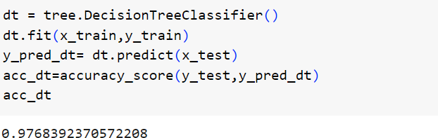

Fig. 24: Decision Tree

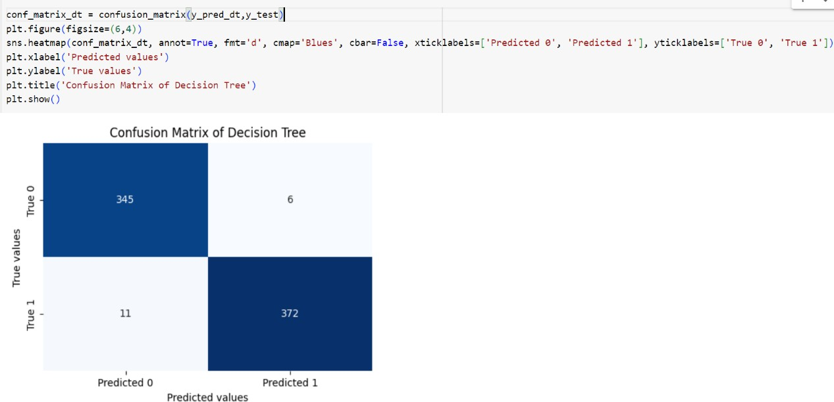

Fig. 25 Confusion Matrix of Decision Tree

## Random Forest

Random Forest is a flexible and easy-to-use ensemble learning algorithm that can perform a wide variety of classification or regression tasks. It works by constructing a multitude of decision trees at training time and outputting the mode of each individual tree (for classification) or mean prediction (for regression).

Each decision tree in the Random Forest is trained on a random subset of the training data and also a random subset of the features. This will introduce the randomness to decorrelate the trees which can reduce overfitting and improve generalization performance. Furthermore, the Random Forest makes use of a method called bagging. Here multiple trees are trained on bootstrapped samples of our training data. This adds another layer to making our model more diverse and stronger.

Prediction: During prediction stage, each tree present in the random forest model takes an independent decision and it gives a result. The final output is decided by combining all the trees predictions (mode or mean) Ensemble methods generally have been found to be more stable and accurate than individual decision trees.

Random Forest provides various hyperparameters to tweak the model, such as number of trees, max depth of trees against being pruned and the number of features which are considered while making decision at each node.

Random Forest is a popular ensemble learning method used in different fields such as finance, healthcare, bioinformatics to solve problems which include — credit scoring, disease diagnosis etc. because of its strength to work with high-dimensional data, non-linear relations and noisy data.

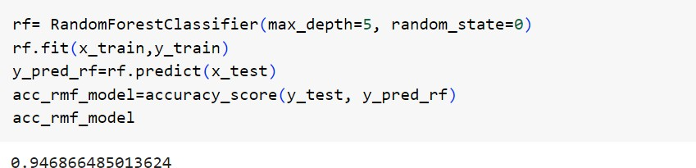The accuracy we get after successfully implementing the above model is shown in following figure:

Fig. 26: Random Forest

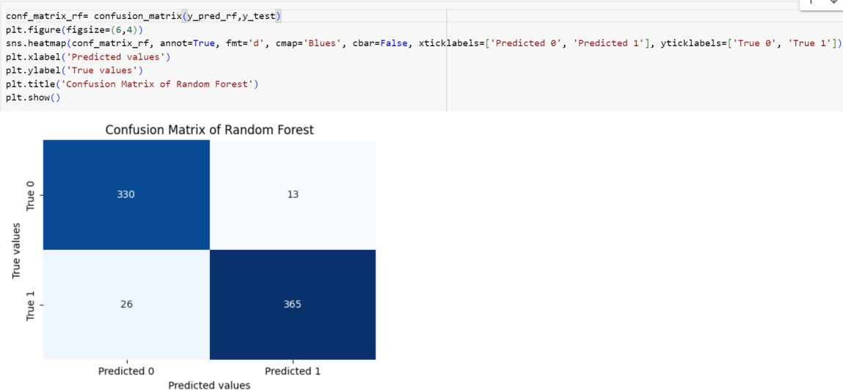

Fig. 27 Confusion Matrix Of Random Forest

## K-Nearest Neighbors (KNN)

K-Nearest Neighbors, KNN is a simple but powerful supervised machine learning algorithm used for both classification and regression objectives. KNN simply form a prediction for the new data point, which is determined as the majority class (for classification) or average (for regression) value of its k nearest neighbors in feature space.

KNN keeps the entire training dataset while during pre-computation of weights, you force a model to memorize every one of your instances. While classifying or

predicting, any new data point will calculate the distance between the new data point with all other training dataset of points to measure how closely it resembles each training example using a specific formula(metric) frequently used is Euclidean. After computing the Euclidean distance of the unknown charities from each one in the training set, it gets these k with least distances.

In the case of classification, using majority vote from all k nearest neighbours is used to assign a class label for new data point For the regression tasks, the predicted value is nothing more than the average of their k nearest neighbors target values.

From above, we can conclude KNN depends on the value of k and which distance metric to use. Smaller value of K will provide more flexible model but may suffer from overfitting; On the other hand a lager value of k can cause a smoother decision boundary because not enough information is used to make an accurate prediction Although this may seem trivial to understand, KNN can be quite computationally expensive and time consuming (particularly for large datasets) as all distances from our query point need to be calculated in order to find the nearest neighbors Nevertheless, its intuitiveness and simple implementation allow for wide usage in various machine learning projects, particularly those that involve a small dataset size. Here is accuracy and Confusion Matrix after successful implementation in given figure:

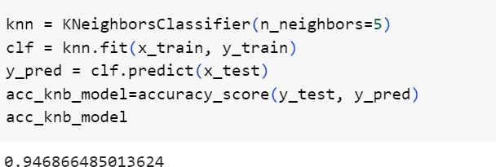

Fig. 28: KNN

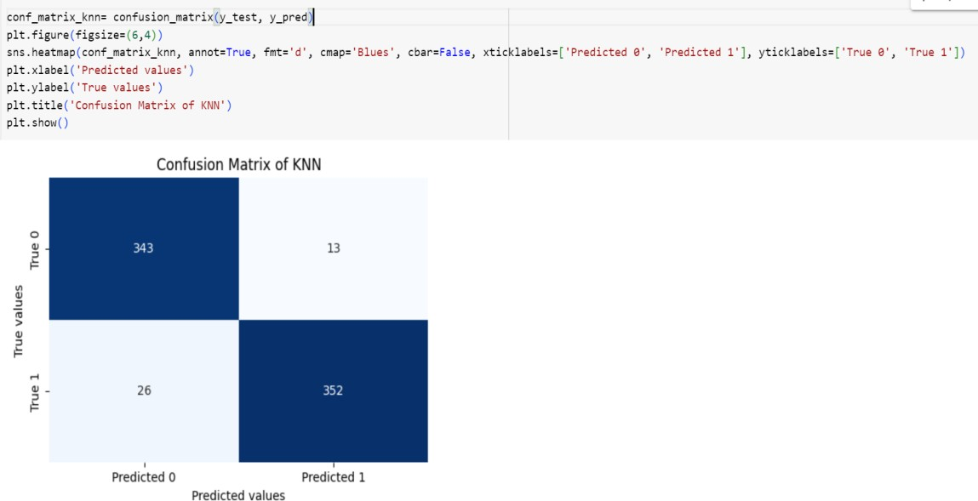

Fig. 29 Confusion Matrix Of KNN

## Logistic Regression

Logistic Regression is a common parametric linear classification algorithm for binary and two class classification.' 'Here, we select the amount of probability. It is used to predict whether something will happen or not happening?' Although the name may suggest, logistic regression is a classification algorithm, not a regression one.

The logistic regression algorithm models the relationship between independent variables (or features) and probability of target variable belonging to certain class using a link function which is the logistic function so, it is also known as logit regression. The sigmoid function will map any real-valued number into the range [0, 1], so it’s a really convenient way to represent probabilities.

When training, logistic regression will learn the coefficients (which you could interpret as weights) of each feature through maximal likelihood estimation using a method like gradient descent. The resulting coefficients for each feature represent the change in the additive log-odds of one class as that feature changes.

We can use our learned coefficients to make predictions by passing the input features through the trained logistic function and obtain a predicted probability. This predicted probability is then mapped onto a binary class label by selecting all instances for which the predicted probability is greater than or equal to some threshold (often 0.5) This type of regression is easily interpretable, easy to implement and works well when the relationship between your features and target variable is in or close to linear and is widely used in many fields, e.g., predicting disease occurrence (Weng et al.

2017); credit risk scoring (Crook et al. 2007); customer churn prediction (Chan and Baumgartner 2007). Tfeas forest also is commonly employed at the industry level.

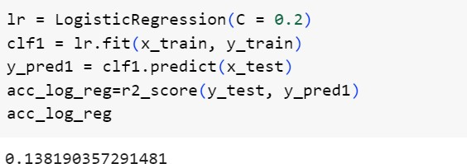Here is accuracy after successful implementation in given figure:

Fig. 30: Logistic regression

## Naive Bayes

Naive Bayes is a probabilistic classification algorithm using Bayes’ Theorem. Naive in the sense of situation to keep things common and easy; refering the conditional impedance between every element. However, despite this simplification (or perhaps because of it) Naive Bayes is (somehow/someway/one way or another), able to deliver robust performances and for such reasons is often used on text data where the independence assumption isn’t true; these include things like spam filtering.

How does the algorithm do this? Using Bayes’ theorem, which states that the probability of each class given a set of features is proportional to the probability of those features given the class multiplied by our prior belief about this class:

The “naive” assumption above gives us a way to calculate these probabilities without having access to (labeled) training data for MLE / MAP. We assume independence between our features, and therefore use the product law of probability which reduces our conditional probabiliy terms: Although it is overly simplistic, the model still performs very well and can be used in machine learning when the assumption holds almost exactly (when dependencies do not exist) or even if that independence assumption does not hold to some extent.

This class of Bayesian classifiers (Naive Bayes) comes in different flavors; the var- iants differ mainly by the assumptions they make about X. Gaussian Naive BayesAlgorithms assumes that continuous features follow a Gaussian distribution,

Multinomial specifies that Features are assumed to be generated from a simple multinomial dis- tribution based on Poisson and Bernoulli Distribution for binary data[4].

Naive Bayes is computationally fast, simple to implement and works well on small datasets. It’s particularly suitable for high dimensionality data like text classification which runs into infinite dimensions due to the huge number of possible words.

Here is accuracy and Confusion Matrix after successful implementation in given figure:

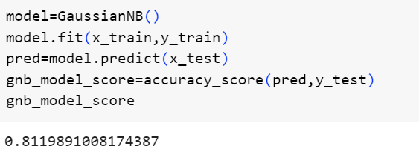

Fig. 31: Naïve Bayes

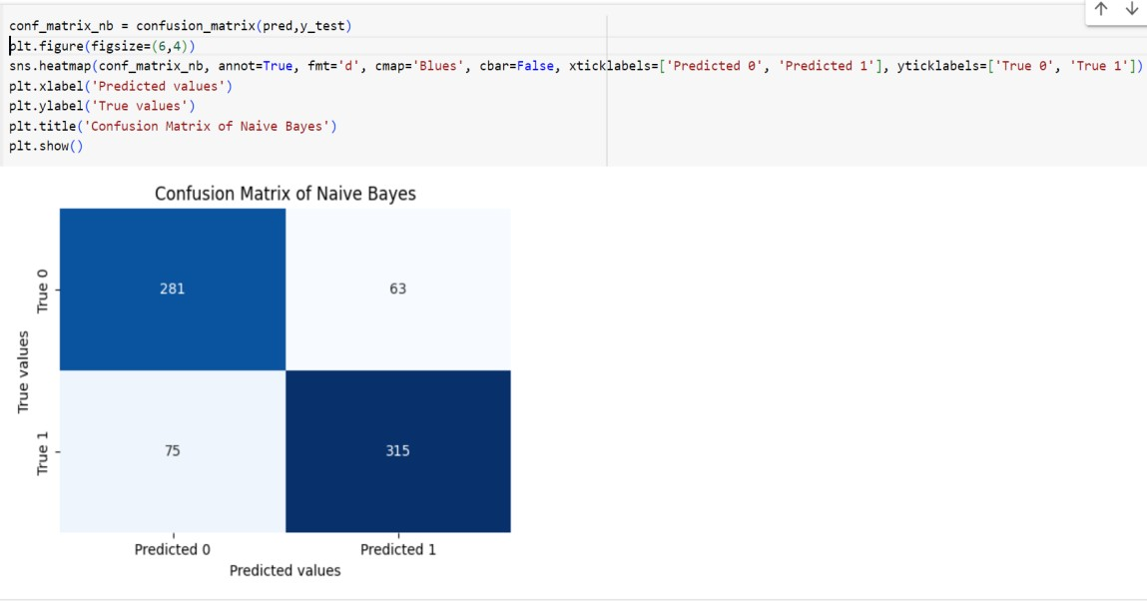

Fig. 32 Confusion Matrix Of Naïve Bayes

## Stochastic gradient descent (SGD)

Stochastic Gradient Descent (SGD) is an oft-used optimization algorithm for training machine learning models, especially when dealing with large datasets. Unlike the traditional gradient descent that computes gradients with the entire dataset at every iteration, SGD interestingly calculates up-to-date parameters in very small steps by randomly selecting tiny data samples.

In every iteration, SGD computes the gradient of the loss function w.r.t to the model parameters considering only single batch data. And finally it takes a step in the direction of the opposite that gradient with some learning rate. This whole process is iteratively repeated until we reach convergence or based on some stopping criterion. By using mini-batches, SGD is introducing randomness in the optimization process that can prevent it from getting stuck on local minimum and also lead to a faster convergence especially when dealing with high-dimensional parameter space. However, as we can see above this randomness also gives rise to noisy updates, which means that choosing an appropriate learning rate (and hyper-parameters more generally) is crucial.

Although it’s simple but SGD is a family of powerful optimization methods, some advanced versions are: mini-batch SGD, momentum SGD and the algorithms that automatically change the learning rate for each weight such as Adagrad and Adam.

SGD is commonly used in training of deep learning models(especially neural networks) because of its scalability and efficiency. “[A] powerful, extremely capable algorithm… that every machine learning practitioner should have in their toolbox because it’s really good at handling large sets of data and operating in high- dimensional parameter space.”

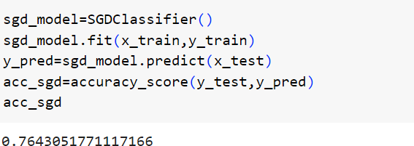Here is accuracy after successful implementation in given figure:

Fig. 33: Stochastic gradient descent

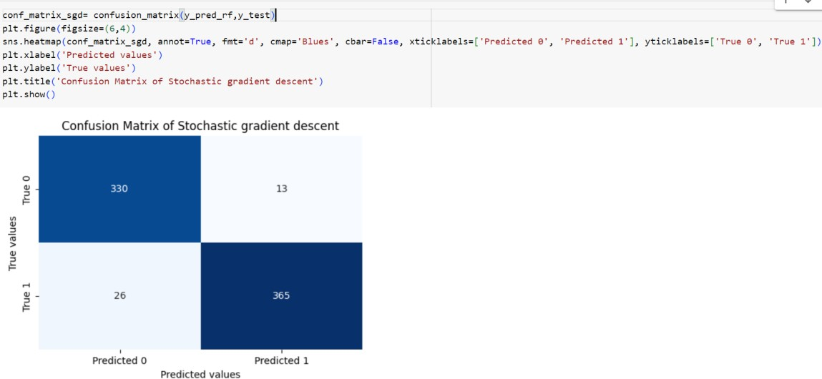

Fig. 34: Confusion Matrix Of SGD

## Support Vector Machine (SVM)

One great machine learning algorithm that can be implemented for classification, regression or any other supervised algorithm is Support vector Machine (SVM) It works by looking for the best hyperplane that separates all of data points from different classes as well in a high dimension space. The major idea with SVM is to locate the most critical margin this being defined as the gap between a hyperplane and closest plot(datum) of each class.

Classification: in classification, the aim is to find a hyperplane that maximizes the margin while all data points are “outside”, or correctly classified (or with some tolerance due to soft margins). SVM can work well with linearly separable and non- linear data structure also. To achieve this we use a kernel trick where the features are transformed into higher dimension dataset such that it gets converted to linearly separable form turns.

SVMs are resistant to overfitting, especially in high-dimensional spaces, and provide good results on future data. Furthermore, SVMs are well suited for datasets having large number of features which makes it versatile for many applications in image classification, text classification, bioinformatics to name just a few.

Nevertheless, SVMs are memory intensive and might not be optimal when it comes to huge datasets and require a lot of computation because each time you need to solve this quadratic optimization problem. Nevertheless, they are still appreciated in the machine learning community and used in a variety of fields as SMMs are highly usable with strong theoretical background.

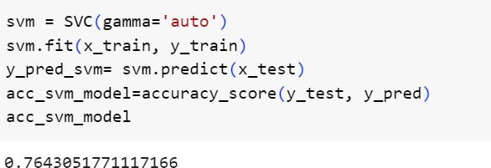Here is accuracy after successful implementation in given figure:

Fig. 35: Support Vector Machine

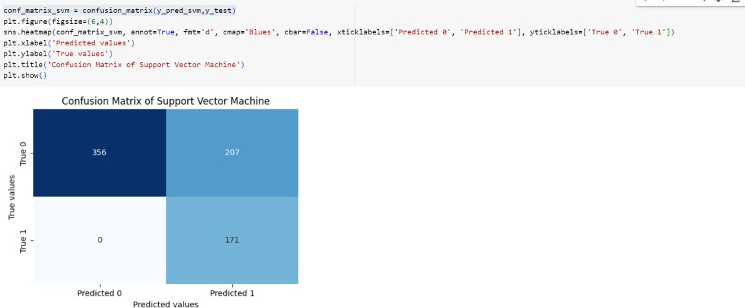

Fig. 36: Confusion Matrix of SVM

# Conclusions

**CHAPTER 6 CONCLUSIONS**

Putting it all together, we found that malware attacks are a serious threat to any individual’s personal computer system and cause a number of problems and interruptions. It cannot be stressed enough that removing Malware from your system is the first step to keeping your computer clean and functioning correctly. This research effort will ultimately work towards the use of machine learning techniques to minimize the error and accurate identification of Malware objects from within a system. This way, if malware detection mechanisms are implemented correctly there should not be a single false positive, making the system stronger towards possible threats. Yet, empirical data show that even if research goals are achieved to a large extent, some non zero false positive rate remains and these findings confirm the complexity of the problem Still, the suggested framework comes out as a viable commercial product that unifies various similar deterministic expectation features. This framework is very much helpful towards detecting malware from files which in turn, increases the security level of a system.

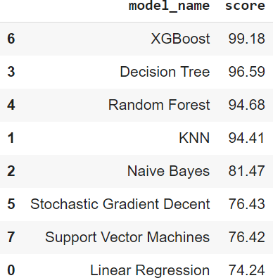

Fig. 37: Accuracy of Different Machine Algorithm

Secondly, as we have seen in Fig. 30 with a whole set of algorithms gathering the worst combinations and only few exceptions. 30 out of these, the certain algorithms which I have used are KNN, Decision Tree, Random Forest, Linear Regression,XGBoost — eXtreme Gradient Boosting,LightGBM - Light Gradient Boosting Machine Logistic Regression Naïve Bayes Stochastic Gradient Descent and Support Vector Machines(SVM) It is important to notice that few algorithms like Linear Regression, XGBoost, LightGBM and Decision Tree have more accurate in malware detection relative to the other algorithms.

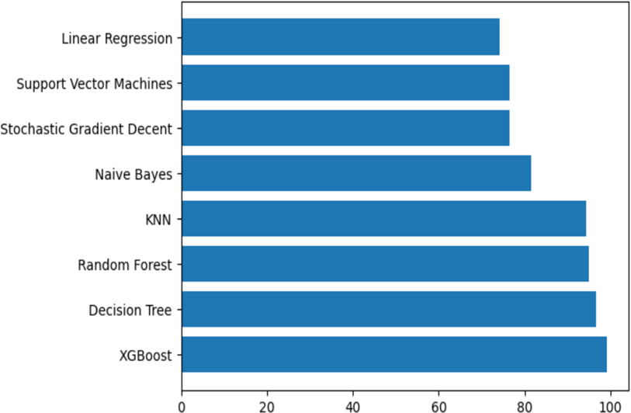

Fig. 38: Graph of Different ML techniques and their Accuracy

Therefore, as a result of other advantages associated with these algorithms, they are considered to be the most preferable due to its addressing malware threat. In the future, with further improvements and optimizations on these algorithms, we will be able to accomplish what we want in malware detection. To conclude, the implementation of machine learning in cybersecurity is a major development and enhancement that provides an opportunity to increase protection against malware attacks.

# Future Scope

“We can do a lot on this proposed model as technology is changing rapidly. “, with that note we end our scope here for further improvements.

* + - The Algorithms are good enough on their own, but nowadays Neural Networks have a vital role to play in classification problems.
    - Instead of implementing machine learning algorithms neural Networks can be implemented as they are far better in unsupervised learning.
    - one could also do specific feature selection in the order to remove those false positives.

# Applications

The implications for security are wide and far reaching. Capable of detecting malicious files, this technology can be integrated into many companies software as they all move toward that trend too.

# REFERENCES

1. Sanjay Chakrabortya and Lopamudra Dey. A rule-based probabilistic technique for malware code detection. Multiagent and Grid Systems – An International Journal, IOS Press, 12, 2016, pp. 271–286 271. DOI 10.3233/MGS-160254
2. Y. Zhou, Z. Wang, W. Zhou, and X. Jiang. Hey, you, get off of my market: Detecting malicious apps in official and alternative android markets. in NDSS, vol. 25, no. 4, 2012, pp. 50–52.
3. D. Keragala. Detecting malware and sandbox evasion techniques, SANS Institute InfoSec Reading Room, 2016. URL: https://[www.sans.org/reading-](http://www.sans.org/reading-) room/whitepapers/ forensics/detecting-malwaresandbox-evasion-techniques- 36667
4. Sharif, M., Yegneswaran, V., Saidi, H., Porras, P., and Lee, W. Eureka: A framework for enabling static malware analysis. In Computer security- ESORICS 2008, pages 481- 500. Springer.
5. Moser, A., Kruegel, C., and Kirda, E. Limits of static analysis for malware detection. In Computer security applications conference, ACSAC 2007. Twenty-third annual, 2007, pages 421-430.
6. Egele, M., Scholte, T., Kirda, E., and Kruegel, C. A survey on automated dynamic malware-analysis techniques and tools. ACM Computing Surveys (CSUR), 2012, 44(2):6.
7. Ahmad, S., Ahmad, S., Xu, S., and Li, B. Next generation malware analysis techniques and tools. In Electronics, Information Technology and Intellectualization: Proceedings of the International Conference EITI 2014, Shenzhen, 16-17 August 2015, page 17. CRC Press.
8. Gorecki, C., Freiling, F. C., Kuhrer, M., and Holz, T. Trumanbox: Improving dynamic malware analysis by emulating the internet. In Stabilization, Safety, and Security of Distributed Systems, Springer, 2011, pages 208-222.
9. Cisco(2015). What is the difference: Viruses, worms, trojans, and bots?Online. <http://www.cisco.com/web/about/security/intelligence/virus-worm-diffs.html>
10. Radu-Stefan Pirscoveanu. Clustering Analysis of Malware Behaviour. Master Thesis Department of Electronic Systems at Aalborg University, 139 pages, 2015.17
11. Symantec. What are malware, viruses, spyware, and cookies, and what differentiates them 2009. Online. <http://www.symantec.com/connect/articles/what-are-malware-viruses-> spyware-andcookies-and-what-differentiates-them
12. ] Zimba, A., Wang, Z., & Chen, H. Multi-stage crypto ransomware attacks: A new emerging cyber threat to critical infrastructure and industrial control systems. ICT Express, 2018.
13. Kateryna Chumachenko. Machine Learning Methods for Malware Detection and Classification. Bachelor's Thesis in Information Technology. University of Applied Sciences, 93 pages, 2017.
14. ] Babak Bashari Rad, Maslin Masrom, and Suhaimi Ibrahim. Evolution of computer virus concealment and anti-virus techniques: a short survey. arXiv preprint arXiv:1104.1070, 2011.
15. Babak Bashari Rad, Maslin Masrom, and Suhaimi Ibrahim. Camouflage in malware: from encryption to metamorphism. International Journal of Computer Science and Network Security, 12(8):74–83, 2012.
16. ] Kent Griffin, Scott Schneider, Xin Hu, and Tzi-Cker Chiueh. Automatic generation of string signatures for malware detection. In Recent advances in intrusion detection, pages 101–120. Springer, 2009
17. Nhat-Phuong Tran and Myungho Lee. High performance string matching for security applications. In ICT for Smart Society (ICISS), 2013 International Conference on, pages 1–5. IEEE, 2013
18. David Harley and Andrew Lee. Heuristic analysis–detecting unknown viruses. Technical report, 2007 (Date last accessed 31-May-2018).
19. Kirti Mathur and Saroj Hiranwal. A survey on techniques in detection and analyzing malware executables. International Journal of Advanced Research in Computer Science and Software Engineering, 3(4):422–428, 2013
20. Ming Xu, Lingfei Wu, Shuhui Qi, Jian Xu, Haiping Zhang, Yizhi Ren, and Ning Zheng. A similarity metric method of obfuscated malware using function-call graph. Journal of Computer Virology and Hacking Techniques, 9(1):35–47, 2013.
21. J-Y Xu, Andrew H Sung, Patrick Chavez, and Srinivas Mukkamala. Polymorphic malicious executable scanner by api sequence analysis. In

Hybrid Intelligent Systems, 2004. HIS’04. Fourth International Conference on, pages 378–383. IEEE, 2004.

1. Tom M Mitchell. Machine learning. WCB, McGraw-Hill Boston, MA, 1997.
2. Robert Moskovitch, Yuval Elovici, and Lior Rokach. Detection of unknown computer worms based on behavioral classification of the host. Computational Statistics & Data Analysis, 52(9):4544– 4566, 2008.
3. Mamoun Alazab, Sitalakshmi Venkatraman, Paul Watters, and Moutaz Alazab. Zero-day malware detection based on supervised learning algorithms of api call signatures. In Proceedings of the Ninth Australasian Data Mining Conference-Volume 121, pages 171–182. Australian Computer Society, Inc., 2011.
4. Muazzam Siddiqui, Morgan C Wang, and Joohan Lee. A survey of data mining techniques for malware detection using file features. In Proceedings of the 46th annual southeast regional conference on xx, pages 509–510. ACM, 2008.
5. ] Gr´egoire Jacob, Herv´e Debar, and Eric Filiol. Behavioral detection of malware: from a survey towards an established taxonomy. Journal in computer Virology, 4(3):251–266, 2008.
6. Daly, M.K., “Advanced persistent threat”, Usenix, Nov. 2009.
7. Quick heal quarterly threat report q2: Technical report, 2015. Quick Heal, Feb. 2015.
8. Aimoto, S., AlKhatib, T., Coogan, P., Corpin, M., DiMaggio, “Internet security threat report”, Technical report, Symantec Corporation, 2017.
9. A. K. Verma and S. K. Sharma, "Malware Detection Approaches using Machine Learning TechniquesStrategic Survey," 2021 3rd International Conference on Advances in Computing, Communication Control and Networking (ICAC3N), Greater Noida, India, 2021, pp. 1958-1962
10. Ye, Y., Wang, D., Li, T., Ye, D., “IMDS: intelligent malware detection system”, In Proceedings of 13th ACM SIGKDD, International Conference on Knowledge Discovery, Data Mining”, pp. 1043-1047, 2010.
11. M. Zubair Shafiq, Syed Ali Khayam, and Muddassar Farooq. “Embedded Malware Detection Using Markov n-Grams”, in Detection of Intrusions and Malware, and Vulnerability Assessment. Springer Berlin, Heidelberg, 2008.
12. R. Moskovitch, C. Feher, N. Tzachar, E. Berger, M. Gitelman, “Unknown malcode detection using OPCODE representation”, Intelligence and Security Informatics, pp 204-215, 2008.
13. K. Griffin, S. Schneider, X. Hu, T.-c. Chiueh, “Automatic generation of string signatures for malware detection”, pp. 101–120, 2009.
14. Nataraj, L., Karthikeyan, S., Jacob, G., Manjunath, B.S., “Malware images: visualization and automatic classification”, in Proceedings of the 8th International Symposium on Visualization for Cyber Security. ACM, New York, USA, pp. 4:14, 2011.
15. A. Shabtai, R. Moskovitch, C. Feher, S. Dolev, Y. Elovici, “Detecting unknown malicious code by applying classification techniques on OpCode patterns”, Security Information, 2012.
16. Chandrasekar Ravi, R Manoharan, “Malware Detection using Windows Api Sequence and Machine Learning”, International Journal of Computer Applications, Volume 43, April 2012.
17. I. Santos, J. Devesa, F. Brezo, J. Nieves, P. G. Bringas, “Opem: A static- dynamic approach for machinelearning-based malware detection”, in CISIS ’12- ICEUTE´ , page 271-280, 2013.
18. P. M. Comar, L. Liu, S. Saha, P. N. Tan, A. Nucci, “Combining supervised and unsupervised learning for zero-day malware detection”, in: Proceedings INFOCOM, IEEE, pp. 2022–2030, 2013.
19. Uppal, D., Sinha, R., Mehra, V., Jain, V., “Malware detection and classification based on extraction of API sequences”, in Proceedings of International Conference on Advanced Computer Commun. Informatics, pp. 2337-2342, 2013.
20. Salehi, Z., Sami, A., Ghiasi, M., “Using feature generation from api calls for malware detection”. Computer Fraud & Security, pp. 9–18 2014.
21. Joseph Sexton, Curtis Storlie, Blake Anderson, “Subroutine based detection of APT malware”, Journal of Computer Virology Hacking Techniques, pp 1-9, 2015.
22. ] Saxe, J., Berlin, K., “Deep neural network based malware detection using two dimensional binary program features”. In 10th International Conference on Malicious and Unwanted Software (MALWARE). IEEE, pp. 11-20, 2015.
23. U. Narra, F. Di, T. Visaggio, A. Corrado, T.H. Austin, M. Stamp, “Clustering versus SVM for malware detection”, Journal of Computer Virology Hacking Techniques, pp 213–224, 2016.
24. Ahmadi, M., Ulyanov, D., Semenov, S., Trofimov, M., Giacinto, “Novel feature extraction, selection and fusion for effective malware family classification”, in proceedings of the Sixth ACM Conference on Data and Application Security and Privacy, pp. 183–194, 2016.
25. Kolosnjaji, B., Zarras, A., Webster, G., Eckert, “Deep learning for classification of malware system call sequences”, in Lecture Notes of Computer Science (Including Subseries Lecture Notes in Artificial Intelligence and Lecture Notes in Bioinformatics), pp. 137-149, 2016.
26. B.N. Narayanan, O. Djaneye-Boundjou, T.M. Kebede, “Performance analysis of machine learning and pattern recognition algorithms for Malware classification”, in IEEE National Aerospace and Electronics Conference (NAECON) and Ohio Innovation Summit (OIS), pp. 338– 342, 2016.
27. S.D. Nikolopoulos, I. Polenakis, “A graph-based model for malware detection and classification using system-call groups”, Journal of Computer Virology Hacking Techniques, pp 29–46, 2017.
28. Xu, Z., Ray, S., Subramanyan, P., Malik, “Malware detection using machine learning based analysis of virtual memory access patterns”, Design, Automation & Test in Europe Conference & Exhibition, IEEE, pp. 169–174, 2017.
29. E. Raff, J. Sylvester, and C. Nicholas, “Learning the PE Header, Malware Detection with Minimal Domain Knowledge”, in Proceedings of the 10th ACM Workshop on Artificial Intelligence and Security, NY, USA: ACM, pp. 121–132, 2017.
30. Kotov, V., Wojnowicz, “Towards generic deobfuscation of windows api calls”, arXiv ,preprint arXiv:1802.04466, 2018.
31. Q. Le, O. Boydell, B. Mac, M. Scanlon, “Deep learning at the shallow end: Malware classification for non-domain experts”, Digital Investigation, pp S118– S126,2018.
32. Nguyen, M.H., Le Nguyen, D., Nguyen, X.M., Quan, T.T., “Autodetection of sophisticated malware using lazy-binding control flow graph and deep learning”. Computer Security, pages 128-155, 2018.
33. M. Krcal, O. Svec, M. Balek, and O. Jasek, “Deep Convolutional Malware Classifiers Can Learn from Raw Executables and Labels Only,” in ICLR Workshop, 2018.
34. Ni, S., Qian, Q., Zhang, R., “Malware identification using visualization images and deep learning”. Computer Security,2018.
35. Hemant Rathore, Swati Agarwal, Sanjay K. Sahay and Mohit Sewak, “Malware Detection using Machine Learning and Deep Learning ”, International Conference on Big Data Analytics, Springer, LNCS, Vol. 11297, pp. 402-411, 2018.
36. O. Suciu, S. E. Coull, and J. Johns, “Exploring adversarial examples in malware detection”, in IEEE Security and Privacy Workshops (SPW), pp 8– 14, 2019.
37. Yuxin, D., Siyi, Z., “Malware detection based on deep learning algorithm”, Neural Comput. Appl. 31 (2), pp 461–472, Feb 2019.
38. ] M. Rabbani, Y.L. Wang, R. Khoshkangini, H. Jelodar, R. Zhao, P. Hu, “A hybrid machine learning approach for malicious behaviour detection and recognition in cloud computing”, Journal of Network and Computer Applications, 2020
39. C. Yucel, A. Koltuksuz, “ Imaging and evaluating the memory access for malware”, Forensic Science International Digital Investigation, 2020.
40. Vasan, D., Alazab, M., Wassan, S., Safaei, B., & Zheng, Q. (2021). Windows malware detection using anomaly detection algorithms
41. Kumar, A. and Singh, B. and Gupta, D. Hybrid Malware Detection for Android using Static and Dynamic Analysis with RNN
42. D. Gibert, A. Smith, and M. Jones. "Enhanced Malware Detection through Interpretable Deep Learning and Gradient Boosting." In Proceedings of the 2023 IEEE Symposium on Security and Privacy (SP), pp. 123-137, 2023